**Index**

|  |  |  |
| --- | --- | --- |
| **Chapter** | **Topic** | **Page No.** |
|  | **Introduction** |  |
| 1 | Company Profile |  |
| 2 | Abstract |  |
| 3 | Existing System and Need for System |  |
| 4 | Scope of System |  |
| 5 | Operating Environment- Hardware and Software |  |
| 6 | Brief Description of Technology Used |  |
|  | **Proposed System** |  |
| 1 | Study of Similar Systems (Literature Survey) |  |
| 2 | Feasibility Study |  |
| 3 | Objectives of Proposed System |  |
| 4 | User Requirements |  |
|  | **Analysis & Design** |  |
| 1 | System Requirements (Functional and Non-Functional Survey) |  |
| 2 | Data Flow Diagrams (DFD) |  |
| 3 | Entity Relationship diagram(ERD) |  |
| 4 | Table structure |  |
| 5 | Use Case diagram |  |
| 6 | Class base diagram |  |
| 7 | Activity diagram |  |
| 8 | Sequence diagram |  |
|  | **Testing** |  |
| 1 | Test Strategy |  |
| 2 | Test Case / Test Script |  |
| 3 | Defect Report / Test Log |  |
|  | **Limitations of the Proposed System** |  |
|  | **Proposed Enhancements** |  |
|  | **Conclusion** |  |
|  | **Bibliography** |  |

**Osumare Marketing Solutions Pvt. Ltd.**

**Company Profile**

**Overview:**

Osumare Marketing Solutions Pvt. Ltd. is a premier global digital marketing agency that delivers exceptional services and innovative solutions. With a clear vision to become the benchmark in digital marketing, we focus on driving our clients' success through knowledge, motivation, skill development, and consistency. Our mission is encapsulated in our motto: Converge, Collaborate, and Change!

We pride ourselves on our client-centric approach, creating unique and compelling software and solutions that resonate with energy, resourcefulness, and responsiveness. Our comprehensive strategies ensure long-term growth and success for our clients locally and globally.

Headquartered in Pune, India, and with offices in Mumbai, Gurugram, Nashik, Jersey City (USA), and Dubai (UAE), Osumare is well-positioned to serve a diverse clientele across the globe. Reach out to us to discover how we can help your business thrive in the digital age.

**Mission:**

**Our motto is simple: Converge, Collaborate, and Change!**

Fueled by our love for digital marketing, our main focus is aligning our goals with our clients’ and working together for amazing results. We’re all about helping our clients connect with their target audience, team up with valued users, and turn them into satisfied clients. Our customers are our treasure, so we dedicate ourselves to creating unique, compelling software and solutions that capture energy, resourcefulness, and responsiveness. We tirelessly build connections with clients, offering comprehensive solutions and clever strategies for long-term growth, both locally and globally. It’s all about working together to make our clients’ goals a reality.

**Vision:**

At Osumare, we dream of being a top-notch global digital marketing agency. Our goal is simple: to be the absolute best and set the standard for top-quality services. We cherish our clients like family, and our vision is all about where we see our clients in the future, because their success is our success. We focus on knowledge, motivation, skill development, adopting the right mindset, and staying consistent. Our main aim is to deliver lasting results for our clients. In the world of internet marketing and 360-degree marketing services, we see ourselves as pioneers and trendsetters, aiming to be the go-to choice for businesses. Our success is tied to making sure our clients thrive.

**Services:**

Osumare offers a wide array of services tailored to meet diverse business needs:

* Digital Marketing: SEO, SEM, SMM, SMO, SMA, ORM, Mobile Marketing, Content Marketing, and 360 Digital Marketing.
* Branding: Infographics, 2D Animation, Graphic Design, Corporate Video Production.
* Web Development: Website Designing, App Development, E-Commerce Development, Software Development, Software Testing.
* Industry Solutions: Specialised services for sectors including cafes, hotels, architecture, restaurants, real estate, IT, automobile, food industry, interior design, heavy engineering, political campaigns, and agriculture.

**Leadership:**

Osumare is spearheaded by Umesh Ahirrao, the visionary Managing Director who has transformed traditional marketing approaches into data-driven strategies. His leadership is pivotal to Osumare’s success and innovation in the digital marketing landscape.

**Company Details:**

* Founded Year: 2012
* Location: Pune, India

**Team:**

Our team comprises seasoned professionals including senior graphic designers, web leads, account managers, digital marketing managers, project managers, and full stack developers. Each team member brings unique expertise and a commitment to excellence, ensuring high quality service delivery and client satisfaction.

**Contact Details:**

* Phone: 96041 53943
* Email: [hr@osumare.in](mailto:hr@osumare.in)

**Social Media:**

**•** LinkedIn: https://www.linkedin.com/company/osumare/

• Twitter: <https://x.com/Osumare_Sol>

•Instagram: https://www.instagram.com/osumaremarketingsolutions/

**Abstract**

**Name of the Project – Our**

**Name of the Client – Umesh Ahirrao**

**Introduction:**

**Our Real Estate Platform** is an advanced, multi-tiered property management solution designed to streamline real estate operations across diverse organisational roles. With a robust architecture supporting seven distinct dashboards—**Super Admin, Admin, Sales Head, Sales Executive, Accountant, User, and Legal Team**—the platform ensures seamless coordination, real- the platform ensures seamless coordination, real-time insights, and enhanced decision-making capabilities at every level.

1. **Super Admin Dashboard**: This serves as the control centre, offering complete oversight of platform activities. Super Admins can manage user roles, configure system settings, monitor transactions, and ensure platform compliance.
2. **Admin Dashboard**: Equipped with tools for day-to-day management, the admin dashboard facilitates property listings, user account management, and regional data tracking to optimise property visibility and client interactions.
3. **Sales Executive Dashboard**: Designed for real-time property updates and client engagement, this dashboard allows sales executives to track leads, schedule property visits, and manage client communication efficiently.
4. **Sales Head Dashboard**: Focused on performance analysis and team coordination, the Sales Head dashboard provides visibility into sales metrics, team activities, and strategic planning to boost sales effectiveness.
5. **Accountant Dashboard**: The accountant dashboard streamlines financial management and enables transaction monitoring, invoice generation, and financial reporting, ensuring accuracy and compliance in all monetary transactions.
6. **User Dashboard**: Tailored for property seekers and owners, the User Dashboard simplifies property searches, booking inquiries, and communication with agents, enhancing the user experience.
7. **Legal Team Dashboard**: Ensuring property transactions are legally sound, the Legal Team dashboard allows document verification, compliance checks, and legal case tracking to safeguard all deals.

Our Real Estate Platform bridges technology and real estate expertise to deliver a seamless experience for all stakeholders. Its dashboard-centric approach guarantees role-specific efficiency, data-driven decision-making, and streamlined property management across the entire platform.

1. **Authentication and User Management:**

* User Registration
* Login and Logout
* Role-based Access Control (Super Admin, Admin, Sales Executive, Sales Head, Accountant, User, Legal Team)
* Password Recovery and Update

1. **Property Management:**

* Post Property Listings
* Edit and Update Property Details
* View Posted Properties
* Manage Property Status (Active, Inactive, Sold)
* Delete Property

1. **Search and Filters:**

* Advanced Property Search (Location, Price, Type, Availability)
* Filter by Amenities, Price Range, Property Type
* Real-time Suggestions and Map-based Search

1. **Wishlist Management:**

* Add to Wishlist
* View Wishlist
* Remove from Wishlist

1. **Enquiry Management:**

* Post Enquiries
* View Enquiries
* Respond to Enquiries
* Track Enquiry Status

1. **Transaction and Financial Management:**

* Manage Payment Record
* Generate Invoices and Receipts
* View Transaction History
* Financial Reporting and Analytics

1. **Subscription Management:**

* Manage Platform Subscriptions
* Renew and Upgrade Plans
* Track Subscription History

1. **Profile Management:**

* Manage Super Admin, Admin, Sales Executive, Sales Head, Accountant, User, and Legal Team Profiles
* Edit and Update Personal Information
* View Activity Logs

1. **Referral and Commission System:**

* Manage Referrals
* Track Successful Transactions
* Automated Commission Calculation (1% of sale value)
* Commission Payout Management

1. **Blog and Content Management:**

* Post Blog Articles
* Edit and Update Blog Content
* View and Share Blogs
* Delete Blog Posts

1. **Legal and Compliance Management:**

* Document Verification
* Legal Case Tracking
* Compliance Checks
* Dispute Resolution Management

1. **Analytics and Reporting:**

* Sales Performance Reports
* Property Analytics (Views, Engagement, Inquiries)
* Financial Reports
* User Engagement Metrics

1. **FAQ and Support Management:**

* Manage Frequently Asked Questions
* Create and Update Support Articles
* Monitor Support Tickets

**Existing System and Need for System**

**Existing System:**

The real estate market in India has seen significant technological advancements over the past decade, with platforms like 99acres, MagicBricks, and NoBroker leading the way in property listings and digital transactions. Below is an overview of the key components of the existing system:

1. **Property Listings and Advanced Search Functionalities:**

* Leading platforms provide comprehensive property listings across residential, commercial, and industrial segments.
* Users can explore properties with advanced search filters, including location, property type, budget, amenities, and possession status.
* Real-time map-based search options allow users to visually explore neighbourhoods and connectivity.

1. **Broker-Free Transactions:**

* Platforms have popularised direct interactions between property owners and potential buyers or tenants, reducing the dependency on intermediaries.
* This approach minimises brokerage fees, speeds up transactions, and provides transparency in negotiations.

1. **Virtual Property Tours and Online Bookings:**

* Modern real estate platforms now feature 3D virtual property tours, 360° views, and live video walkthroughs to help buyers and tenants explore properties remotely.
* Users can schedule visits and book properties online, ensuring seamless engagement without physical constraints.

1. **Legal Assistance and Documentation Management:**

* Existing platforms often provide legal support, including document verification, property registration, and compliance checks.
* In-platform tools for generating legally binding agreements, such as sale deeds and rental agreements, streamline legal formalities.

1. **Financial Services and Home Loans:**

* Leading platforms partner with banks and financial institutions to facilitate home loans, pre-approved mortgages, and EMI calculations.
* Users can compare loan options, check eligibility, and apply directly through the platform, making the financial process smoother.

1. **Property Valuation and Market Insights:**

* Real-time property valuation tools provide users with market-based estimates for buying, selling, or renting decisions.
* Platforms also display historical price trends, demand analysis, and ROI predictions to guide informed decision-making.

1. **Property Management Services:**

* For property owners, advanced platforms offer property management solutions, covering tenant interactions, maintenance tracking, and rental collection.
* These services are particularly beneficial for NRIS (Non-Resident Indians) or landlords managing multiple properties.

1. **Tenant Verification and Background Checks:**

* Built-in verification services ensure that tenants are credible and reliable, reducing risks associated with property rentals.
* Background checks include employment verification, rental history, and identity validation.

1. **Neighbourhood Insights and Local Analytics:**

* Users can explore neighbourhood amenities, schools, hospitals, transportation links, and crime rates directly through interactive maps.
* Local analytics help users understand property value appreciation, rental yield, and lifestyle quality in specific areas.

1. **Customer Support and Chat Assistance:**

* Platforms now offer 24/7 customer support with live chat features to resolve user queries instantly.
* Dedicated support for legal, financial, and property-related questions enhances user experience.

**Need for System:**

The Indian real estate market is rapidly evolving, with increasing demand for technology-driven solutions to overcome traditional barriers. While platforms like **99acres, MagicBricks, and NoBroker** have introduced digital property transactions, there remain significant gaps in efficiency, transparency, and user experience. **Our Real Estate Platform** aims to address these challenges through a robust, multi-dashboard solution that caters to all stakeholders involved in property transactions.

1. **Streamlined Property Transactions:**

* Traditional property transactions are often complicated by broker dependencies, paperwork delays, and a lack of coordination.
* The 99acres Platform digitises the entire transaction process, enabling buyers and sellers to connect, negotiate, and complete deals seamlessly online.
* Key features like virtual property tours, digital documentation, and online booking eliminate the need for multiple site visits and manual paperwork, enhancing convenience and efficiency.

1. **Role-Based Dashboard Management:**

* Unlike conventional platforms, 99acres introduces role-based dashboards—Super Admin, Admin, Sales Executive, Sales Head, Accountant, User, and Legal Team—ensuring that each stakeholder has access to specific functionalities and real-time data.
* This segmentation enhances operational efficiency, accountability, and secure data management, minimising risks of data mismanagement.

1. **Transparency and Trust Building:**

* Property transactions often suffer from hidden charges, incomplete information, and limited legal transparency.
* 99acres addresses these issues by providing comprehensive property listings, verified documentation, legal compliance checks, and transparent pricing.
* Integrated tenant verification and background checks further build trust in rental and sales transactions.

1. **Advanced Analytics and Market Insights:**

* Traditional property dealings lack real-time analytics and market insights, leading to uninformed decisions.
* 99acres integrates data-driven insights, market trend analysis, and property valuation tools to empower buyers, sellers, and agents with informed decision-making capabilities.
* Sales Heads and Admins can also monitor team performance, track revenue, and optimise marketing strategies through dashboard analytics.

1. **Community Engagement and Referrals:**

* The platform promotes community-driven growth through its Referral and Commission system, rewarding users with a 1% commission on successful transactions.
* This feature not only incentivises user engagement but also amplifies organic marketing, extending platform reach through trusted networks.

1. **Legal Compliance and Documentation Management:**

* Navigating legal complexities is a major challenge in property transactions. 99acres simplifies this with its Legal Team Dashboard dedicated to managing document verification, compliance checks, and legal dispute resolution.
* This ensures that all property dealings are legally sound and risk-free.

1. **Adaptability and Scalability:**

* With shifting market trends and regulatory changes, the 99acres Platform is built to adapt seamlessly, offering modular upgrades, real-time feature integration, and compliance with government regulations.
* The architecture supports future enhancements, ensuring scalability as the platform grows.

**Scope of the System:**

The 99acres Real Estate Platform is designed to be a comprehensive property management and transaction solution tailored to the evolving needs of the Indian real estate market. By integrating advanced digital solutions, role-specific dashboards, and end-to-end transaction capabilities, the platform aims to redefine how property dealings are conducted. The scope of the system includes, but is not limited to, the following aspects:

1. **Property Listings and Advanced Search:**

* The platform offers a vast database of residential, commercial, and industrial properties available for sale, rent, or lease.
* Users can search properties based on location, budget, property type, amenities, possession status, and RERA approval.
* Features include interactive map-based searches, 3D virtual tours, and video walkthroughs for enhanced exploration.

1. **Multi-Tier Dashboard Access:**The system supports role-based access with dedicated dashboards for:

* Super Admin: Manages overall platform operations, user roles, data privacy, and compliance.
* Admin: Handles property listings, user account management, and regional operations.
* Sales Executive: Manages client interactions, property visits, and lead generation.
* Sales Head: Monitors team performance, sales analytics, and strategic planning.
* Accountant: Manages financial transactions, invoices, and payment records.
* User: Facilitates property searches, booking inquiries, and Wishlist management.
* Legal Team: Oversees document verification, legal compliance, and dispute resolution.

1. **User Registration and Secure Authentication:**

* New users can easily register and authenticate through OTP verification, email confirmation, and secure login protocols.
* Multi-factor authentication (MFA) ensures user data security and prevents unauthorised access.

1. **Referral and Commission Management:**

* The platform introduces an innovative Referral System that incentivises users with 1% commission on successful transactions generated through their referrals.
* Real-time referral tracking, earning history, and commission payouts are managed directly through the User Dashboard.

1. **Property Management and Status Tracking:**

* Property owners and agents can post, edit, update, and delete property listings.
* Live status updates (Available, Sold, Booked) and price modifications are instantly reflected on the platform.
* The platform supports bulk property uploads for large-scale listings.

1. **Financial Management and Online Payments:**

* The platform integrates secure online payment gateways for booking, rentals, and sales transactions.
* EMI calculators, mortgage eligibility checks, and invoice generation are part of the Accountant's module.
* Financial records are maintained with real-time updates and downloadable reports.

1. **Legal Documentation and Compliance:**

* A dedicated Legal Dashboard allows the legal team to verify documents, perform compliance checks, and track legal cases.
* Automated legal contract generation, e-signatures, and digital archiving simplify documentation.

1. **Customer Support and Communication:**

* Users can communicate directly with property owners, agents, and support staff via in-app messaging and live chat.
* Instant notifications for property inquiries, status changes, and payment confirmations ensure real-time updates.

1. **Analytics and Reporting:**

* The platform provides data-driven insights on sales performance, market trends, property demand, and financial summaries.
* Dashboards display custom reports, real-time analytics, and growth forecasts for strategic planning.

1. **Scalability and Future Readiness:**

* The platform is designed for scalability and modular expansion, allowing for the seamless addition of new features and integrations.
* Regular updates based on user feedback and market trends ensure its relevance and competitiveness in the long term.

**Operation Environment: Hardware and Software:**

The 99acres Real Estate Platform is designed to operate seamlessly across modern hardware and software environments, ensuring high performance, scalability, and user satisfaction. Below are the detailed specifications for both hardware and software requirements.

**Hardware Requirements:**

**Server Infrastructure:**

* High-performance servers are configured to manage web traffic, database queries, and application logic efficiently.
* Multi-core processors (8 cores or more) with a minimum of 16GB RAM for optimal performance.
* SSD-based storage with a minimum of 500GB, expandable based on data growth and property image uploads.
* Load Balancers to handle traffic surges and ensure high availability.
* Reliable network connectivity with high bandwidth to support real-time interactions and video walkthroughs.
* Backup and Disaster Recovery Mechanism to ensure data safety and business continuity.

**Client Devices:**

* Accessible through modern desktop computers, laptops, tablets, and smartphones.
* Compatible with the latest versions of web browsers like Google Chrome, Mozilla Firefox, Safari, and Microsoft Edge.
* Adequate processing power and memory (minimum 4GB RAM for a smooth browsing experience).
* Touch support and responsive display capabilities for mobile and tablet users.

**Software Requirements:**

**Operating System:**

* Server: Linux-based operating systems such as Ubuntu Server (20.04+), CentOS (8+), or Debian (10+).
* Client Devices: Any modern OS including Windows (10+), macOS (Monterey+), Linux, Android (11+), and iOS (14+).

**Web Server:**

* Nginx is configured as a reverse proxy to Node.js application servers.
* SSL/TLS encryption for secure data transactions.

**Database:**

* MongoDB (v5.0+) is the primary database for scalable and flexible data storage.
* Redis for caching frequently accessed data to enhance performance.

**Backend Framework:**

* Built on the MERN Stack (MongoDB, Express.js, Node.js).
* Node.js (v18.0+) for server-side execution.
* Express.js (v4.18+) for building RESTful APIs and routing.

**Frontend Framework:**

* Developed using React.js (v18.0+) for an interactive and responsive user interface.
* Redux for state management across multiple dashboards.
* React Router for client-side routing and navigation.

**Additional Dependencies:**

* Axios for API communication.
* JSON Web Token (JWT) for secure authentication.
* AWS S3 for storing property images and documents.
* Socket.IO for real-time updates and messaging.
* Yup, for form validation.
* React Hook Form

**Deployment Considerations:**

* The platform supports both cloud-based AWS deployment.
* Recommended cloud platforms: AWS (EC2, S3 (Bucket), Route 53, SNS (Text Messaging), SES, IAM User.
* Integrated with CI/CD pipelines using tools like Jenkins, GitHub for smooth deployments.
* Supports Docker for containerization to manage a monolithic architecture efficiently.

**Security Measures:**

* SSL Encryption for secure data transmission.
* Role-Based Access Control (RBAC) for secure multi-dashboard access.
* Data Encryption at Rest utilising AES-256 for robust security.
* Additional data protection through bcryptjs and cryptojs for password hashing and cryptographic functions.
* Regular Vulnerability Assessments and Penetration Testing (VAPT).

**Technology Used:**

**Our Real Estate Platform** is powered by a robust and scalable technology stack designed to ensure high performance, security, and seamless user experience across its multiple dashboards. Below is a breakdown of the technologies utilised:

**Database:**

* **MongoDB (v5.0+)**: Primary database for scalable and flexible data storage.
* **Redis**: Employed for caching frequently accessed data to enhance system performance and reduce latency.

**Backend Framework:**

* **Node.js (v18.0+)**: Used for server-side execution and handling concurrent requests efficiently.
* **Express.js (v4.18+)**: Lightweight web application framework for building RESTful APIs and routing mechanisms.
* **MERN Stack (Mongo****Backend Framework:**  
  **DB, Express.js, React.js, Node.js)** Ensures seamless interaction between frontend and backend, maintaining a unified development experience

**Frontend Framework:**

* **React.js (v18.0+)**: Powers the interactive and responsive user interface.
* **Redux**: Manages the application state effectively across multiple dashboards, ensuring consistent data flow.
* **React Router**: Facilitates smooth client-side routing and navigation within the application.

**Additional Dependencies:**

* **Axios**: For efficient API communication and data fetching.
* **JSON Web Token (JWT)**: Manages secure authentication and session handling.
* **AWS S3**: Stores property images and documents securely and scalably.
* **Socket.IO**: Enables real-time updates and messaging for instant communication across dashboards.
* **Yup**: Simplifies form validation with schema-based validation rules.
* **React Hook Form**: Manages form states with minimal re-renders and improved performance.

**Deployment Considerations:**

* The platform is optimised for **cloud-based AWS deployment**.
* Integrated with **CI/CD pipelines** using tools like **Jenkins** and **GitHub Actions** for smooth, automated deployments.
* **Docker** is used for containerization, enhancing application scalability and simplifying deployment.
* Recommended AWS services include:
* **EC2** for scalable server instances.
* **S3 Bucket** for object storage of images and documents.
* **Route 53** for domain management and traffic routing.
* **SNS (Simple Notification Service)** for text messaging alerts.
* **SES (Simple Email Service)** for email notifications.
* **IAM User** for secure access and role management.

S**ecurity Measures:**

* **SSL Encryption** ensures secure data transmission over networks.
* **Role-Based Access Control (RBAC)** to manage access across different dashboards securely.
* **Data Encryption at Rest** using **AES-256** for robust data protection.
* **bcryptjs** and **cryptojs** for password hashing and cryptographic operations.
* Regular **Vulnerability Assessments and Penetration Testing (VAPT)** to identify and mitigate security risks.

**Technology Used – Brief Overview:**

**Database Technologies:**

1. **MongoDB (v5.0+):**

* Nosql database is known for its flexibility and scalability.
* Stores data in a document-oriented format (JSON-like objects), allowing for easy updates and modifications.
* Ideal for managing unstructured data such as property listings, user profiles, and transaction histories.
* Supports sharding and replication for high availability and horizontal scaling.
* Offers powerful query capabilities, indexing, and aggregation for efficient data retrieval.

1. **Redis:**

* In-memory data structure store used for caching frequently accessed data.
* Optimises application performance by reducing database calls and latency.
* Supports data structures such as strings, hashes, lists, sets, and sorted sets.
* Facilitates real-time analytics and live updates with sub-millisecond response times.
* Ensures high availability through replication and persistence.

**Backend Technologies:**

1. **Node.js(v18.0+):**

* JavaScript runtime environment for building scalable server-side applications.
* Event-driven, non-blocking I/O model for efficient processing of multiple concurrent connections.
* Ideal for building real-time applications like chat systems, live property updates, and instant messaging.
* Uses the V8 engine for high-speed code execution.
* Lightweight and easily extendable through NPM packages.

1. **Express.js (v4.18+):**

* Web application framework for Node.js, simplifying backend API development.
* Supports middleware for handling HTTP requests, responses, and error management.
* Facilitates RESTful API creation for seamless client-server communication.
* Enables clean routing and modular application architecture.
* Lightweight, minimal, and easy to integrate with various database systems.

**Frontend Technologies:**

1. **React.js (v18.0+):**

* Frontend JavaScript library for building interactive and dynamic user interfaces.
* Component-based architecture promotes reusability and modularity.
* Virtual DOM enhances rendering speed and improves performance.
* Enables seamless integration with backend APIs for real-time property updates.
* Compatible with various state management solutions like Redux.

1. **Redux:**

* Predictable state management library for JavaScript applications.
* Centralises application state, making debugging and testing more straightforward.
* Enables consistent data flow across multiple components.
* Supports middleware for handling asynchronous operations (e.g., API calls).
* Facilitates undo/redo capabilities and time travel debugging.

1. **React Router:**

* Client-side routing library for seamless navigation in single-page applications.
* Allows dynamic page rendering without refreshing the browser.
* Supports nested routes, parameterised URLs, and navigation guards.
* Enhances user experience with smooth transitions and deep linking.
* Simplifies route management and component-based navigation.

**Additional Dependencies:**

1. **Axios:**

* Promise-based HTTP client for making API requests from the frontend to the backend.
* Supports GET, POST, PUT, DELETE, and other HTTP methods.
* Simplifies error handling and response data extraction.
* Allows for global request configurations and interceptors.
* Ideal for real-time data fetching and submission.

1. **JSON Web Token (JWT):**

* Industry-standard for secure token-based authentication.
* Encodes user credentials into a JSON object and signs it with a secret key.
* Enables stateless authentication, reducing server load.
* Prevents unauthorised access to protected routes and APIs.
* Supports role-based access and multi-level permissions.

**3. AWS S3:**

* Scalable object storage service for property images and documents.
* Ensures high availability and durability of data with global redundancy.
* Supports image optimisation, compression, and access control mechanisms.
* Easily integrates with backend applications for secure file uploads.
* Provides URL-based access for seamless media rendering on the frontend.

1. **Yup:**

* JavaScript schema validation library for form input validation.
* Defines validation rules for form fields like email, password, and property details.
* Offers chaining of validation methods for enhanced accuracy.
* Integrates seamlessly with React Hook Form for real-time error handling.
* Provides custom error messages for a better user experience.

1. **React Hook Form:**

* Lightweight library for building form elements with minimal re-renders.
* Integrates easily with validation libraries like Yup.
* Efficient state management of form inputs.
* Supports asynchronous validation and form submission handling.
* Enhances user experience with instant feedback on errors.

**Deployment Technologies:**

1. **AWS Cloud Platform:**

* Utilises AWS EC2 for hosting, AWS S3 for storage, and AWS Route 53 for domain management.
* AWS SNS (Simple Notification Service) for text messaging alerts.
* AWS SES (Simple Email Service) for transactional emails and notifications.
* IAM (Identity and Access Management) for secure role-based access control.
* Scalable, reliable, and globally distributed infrastructure for high availability.

1. **Docker:**

* Containerization platform for packaging application code with dependencies.
* Ensures consistent development, testing, and production environments.
* Facilitates microservices architecture for isolated service deployment.
* Reduces dependency conflicts and simplifies version control.
* Supports horizontal scaling and rapid deployment

1. **Jenkins & GitHub CI/CD:**

* Jenkins automates build, test, and deployment pipelines.
* GitHub Actions streamlines continuous integration and version control.
* Enables automated testing and code quality checks.
* Simplifies application deployment and rollback processes.
* Ensures rapid delivery and consistent software updates.

**Security Measures:**

1. **SSL Encryption:**

* Encrypts data transmitted between the user and the server, ensuring confidentiality.
* Protects against man-in-the-middle attacks and eavesdropping.
* Essential for secure login, transactions, and sensitive user information.

1. **Role-Based Access Control (RBAC):**

* Manages user permissions based on roles (Admin, Agent, User, etc.).
* Prevents unauthorised access to critical system modules.
* Enhances data privacy and maintains application integrity.

1. **Data Encryption at Rest (AES-256):**

* Protects stored data from unauthorised access and breaches.
* Uses Advanced Encryption Standard (AES) with 256-bit keys.
* Ensures sensitive information like user credentials and transaction data is secured.

1. **bcryptjs and cryptojs:**

* bcryptjs for password hashing, enhancing login security.
* Cryptojs for data encryption and secure token generation.
* Protects user credentials from brute-force and dictionary attacks.

1. **Vulnerability Assessments and Penetration Testing (VAPT):**

* Regular scanning for security loopholes and vulnerabilities.
* Simulated attacks to identify weaknesses and enhance protection.
* Ensures compliance with industry standards and security protocols.

**Chapter 2**

**Proposed System**

**Study of Similar Systems (Literature Survey)**

|  |  |  |  |
| --- | --- | --- | --- |
| **Sr.**  **No.** | **Website**  **Name** | **Modules** | **Drawbacks** |
| **1.** | **99acres** | 1. User Module –   * User Registration/Login (buyers, sellers, agents) * Profile Management * Role-based Access (buyer, seller, broker, admin)   2. Property Listing Module –   * Add Property (with images, price, location, features) * Edit/Delete Property * Property Verification Workflow (admin side) * Categorisation (rent/sale, commercial/residential)   3. Search & Filter Module –   * Search by city, locality, price, property type, BHK, etc. * Advanced Filters (furnishing status, area, amenities) * Map View Integration   4. Property Detail View Module –   * Full property info (images, price, specs, location) * Contact options (phone, message, email) * Save/Bookmark Property   5. Communication Module –   * Messaging between buyer and seller/agent * Enquiry Forms * Notification system (email/SMS/app)   6. Payment Module (Optional in Phase 1)   * Premium Listings * Subscription Plans for Agents * Payment Gateway Integration | Fake or Outdated Listings –   * Many users report seeing properties that are already sold or rented. * Some listings are duplicates or misleading, especially from brokers.   2. Broker Dominance –   * Despite being open to individual users, many listings are posted by brokers. * Brokers often act as middlemen even when owners try to list directly.   3. Limited Verification –   * Property details and ownership are not always verified, leading to trust issues. * The "verified" tag isn't always reliable or thoroughly checked.   4. User Interface (UI) Clutter –   * The desktop version can feel cluttered with ads, pop-ups, and too many options. * Users sometimes find it hard to navigate or focus on the main content.   5. Slow or Ineffective Customer Support –   * Delay in resolving user complaints or disputes. * Limited escalation options for issues like fake listings or payments. |

|  |  |  |  |
| --- | --- | --- | --- |
| **Sr.**  **No.** | **Website**  **Name** | **Modules** | **Drawbacks** |
|  |  | 7.Admin Panel –   * User Management (ban, verify, support) * Property Approval/Moderation * Reported Listings Review   Analytics Dashboard (user activity, traffic, conversions)  8. Blog/Content Module (Optional)   * Tips for buyers/sellers * Market trends * SEO content management   9. Support & Feedback Module-   * Contact Us / Help Desk * Feedback submission   FAQs / Knowledge Base. | 6. High Cost for Premium Services –   * Listing promotions or premium features can be costly for individual sellers or small agencies.   Not ideal for small-scale property owners with limited budgets.  7. App Performance Issues –   * Users have reported bugs, slow load times, or crashes on the mobile app. * Search filters sometimes reset or don’t apply properly.   8. Privacy Concerns –   * Phone numbers of owners/brokers are often visible, leading to spam calls. * No strong anonymisation for user communication.   9. Limited International Reach -   * Mostly focused on Indian real estate; not very helpful for NRIs or international investors looking for localised support.   10. SEO-Driven Content Overload –   * The blog/news sections sometimes prioritise SEO over user-relevant insights. * Can confuse users with too much generic content. |
| 2. | **MagicBricks** | 1. User Management Module-   * User registration/login (Buyer, Seller, Agent, Builder) * Role-based dashboard * Profile management and KYC verification | 1. Fake or Misleading Listings –   * Some property ads are outdated, fake, or posted by brokers pretending to be owners. * Users often report that listed properties are no longer available. |

|  |  |  |  |
| --- | --- | --- | --- |
| **Sr. No** | **Website Name** | **Modules** | **Drawbacks** |
|  |  | 2. Property Listing Module-   * Post property for sale/rent * Edit/renew/delete listings * Upload media (photos, videos, 360° views) * Categorization (Residential, Commercial, New Projects, PGs)   3. Search & Filter Module-   * Keyword-based property search * Advanced filters: BHK, price, locality, furnishing, amenities * Map view and list view * Search by landmark, metro, or builder.   4. Property Detail Module –   * Detailed property description * Nearby amenities map * Price trends and EMI calculator * “Contact Seller” or “Schedule Visit” options   5. Lead Management & Communication Module –   * Direct messaging/calling options * Lead alerts and responses * Integration with WhatsApp and email * Inquiry tracking for sellers and agents   6. Payment & Subscription Module –   * Premium listing plans * Spotlight Ads / Top Placement features. | 2. Broker Overload-   * Many listings are dominated by brokers, even when searching specifically for owner listings. * This reduces trust and causes frustration for buyers looking for direct deals.   3. High Cost for Premium Features-   * Premium listing, spotlight ads, and subscription plans can be expensive for individual sellers.   Limited visibility for free/basic listings.  4. App Performance Issues-   * App can be slow or buggy, especially with search filters and map integration. * Some users report that filters reset or deliver inconsistent results.   5. Poor Listing Quality –   * Listings sometimes have low-quality images or missing important details (like floor plans, carpet area). * No strict content guidelines for media uploads.   6. Weak Verification System-   * "Verified" labels are often not reliable; many users report issues even with verified agents or listings. |

|  |  |  |  |
| --- | --- | --- | --- |
| **Sr. No** | **Website Name** | **Modules** | **Drawbacks** |
|  |  | * Builder plans and packages * Payment gateway integration   7. Admin Panel –   * Property moderation (approve/reject listings) * User management (ban/suspend users) * Report handling (fake listings, fraud) * Analytics dashboard (traffic, user behaviour).   8. Home Loan & Financial Services Module –   * Loan eligibility checker * Loan comparison tool * Integration with banks/NBFCs * Application tracking system   9. New Projects Module-   * Builder/project profile pages * Project comparisons * Construction updates and RERA status * Virtual tours   10. Support & Feedback Module –   * Chatbot and live chat * Contact forms and customer service ticketing * Feedback collection and rating system * FAQs and Help Center | * Identity and property verification can be superficial.   7. Spam Calls & Privacy Issues-   * User phone numbers can be accessed by multiple brokers, leading to spam calls or unwanted follow-ups. * No strong privacy controls or in-app calling system.   8. Limited Customer Support –   * Slow or ineffective resolution of user complaints. * Difficult escalation process for issues like fraud or incorrect billing.   9. Unclear Filters and UI Clutter –   * Advanced filters are sometimes too complex or hidden under layers. * The interface has a lot of options, which can confuse first-time users.   10. Loan/Legal Service Limitations-   * Home loan assistance and legal aid services are often outsourced or limited in scope.   Not as integrated as they appear in ads. |
| **3.** | **NoBroker** | 1. User Module –   * Sign up/Login (Tenant, Owner, Buyer, Seller, Service Provider) * KYC & phone/email verification. | 1. Limited Free Access-   * Only a few owner contacts are available for free. |

|  |  |  |  |
| --- | --- | --- | --- |
| **Sr. No** | **Website Name** | **Modules** | **Drawbacks** |
|  |  | * Profile management (preferences, saved searches)   Property Listing Module –   * Add property (for rent/sale) * Upload photos, amenities, rent details, deposit, etc. * Property categorization (residential/commercial/PG) * Auto-suggestion for locality and nearby landmarks.   3. Search & Filter Module-   * Property search by city, locality, rent, BHK, furnishing, etc. * Advanced filters: pet-friendly, lift, parking, nearby transport * Map-based search * Save search functionality   4. Property Detail View Module –   * Detailed view: description, rent, amenities, photos, owner contact * Price/rent trends and locality insights * Owner contact request (with limited free access)   5. Communication & Lead Module-   * In-app chat or call with property owners * Lead tracking for both tenants and owners * Limited contact reveals for free users (promotes subscription)   6. Subscription & Payment Module-   * Paid plans: Relax Plan, Moneyback Plan, Freedom Plan | * Users must subscribe to paid plans to get full access, which can be frustrating for budget users.   2. Quality of Listings Varies-   * Some listings lack proper descriptions, photos, or accurate details. * Property availability status is not always up to date.   3. Over-Dependence on Subscription Model-   * Too many features (like contacting owners, rent agreement, packers/movers) are behind paywalls. * Free users feel pressured to upgrade, even for basic tasks.   4. App and Site Performance Issues-   * Occasional app crashes or lag during search/filter use. * Bugs reported in chat and messaging features (messages not sending or delays).   5. Customer Support Complaints-   * Users often report poor or slow customer support, especially for refunds or service complaints. * The escalation process is not very transparent. |

|  |  |  |  |
| --- | --- | --- | --- |
| **Sr. No** | **Website Name** | **Modules** | **Drawbacks** |
|  |  | * Credit card, UPI, net banking support * Incoice generation and plan tracking.   7. Admin Panel-   * User and property management * Fraud detection and moderation * Complaint resolution * Analytics dashboard (traffic, leads, conversions)   8. Service Booking Module –   * Rent agreement creation * Packers & movers * Home cleaning & painting * Rental furniture and home loans * Booking calendar, payment, and tracking   9. Legal & Documentation Module-   * Online rent agreement creation * eStamping and eSigning * Doorstep document collection and delivery tracking   10. Support & Feedback Module-   * Ticketing system for issues * FAQs and chatbot * User feedback and reviews * Complaint escalation | Service Delivery Gaps-   * Delays or issues in value-added services (e.g., packers and movers, cleaning). * Third-party vendors may not meet NoBroker's promised standards.   7. Location Coverage Limitations-   * Strong presence in metro cities, but limited or poor-quality listings in smaller towns or tier-2/3 cities. * Lack of hyper-local insights in less developed areas.   8. Inconsistent Verification-   * While NoBroker promises verified listings, some still turn out to be fake or outdated. * Landlord or tenant reviews are limited or missing, which reduces trust.   9. Aggressive Sales Tactics-   * Users sometimes receive too many promotional calls or emails after signing up. * Some feel overwhelmed by marketing pressure to buy premium plans. |

|  |  |  |  |
| --- | --- | --- | --- |
| **Sr. No** | **Website Name** | **Modules** | **Drawbacks** |
|  |  |  | 10. NoBrokerHood Integration Confusion-   * NoBrokerHood (security app for apartments) is marketed alongside NoBroker services, confusing users who only want real estate services. * Different platforms, but mixed branding can create user experience issues. |
| **4.** | **Housing** | 1. User Management Module-   * User registration/login (Buyer, Seller, Agent, Builder) * Social login (Google/Facebook) * Profile management (preferences, saved listings, recent searches)   2. Property Listing Module –   * Add property (for sale/rent/PG/new project) * Upload property images, video tours, and 3D plans * Owner vs. Agent listing flag * Auto-fill location and amenities from database.   3. Search & Filter Module-   * Search by city, locality, price, property type, and number of bedrooms * Map-based search view. * Smart filters: furnished, ready-to-move, resale/new, RERA approved * Save searches and receive alerts | 1. Limited Listings in Smaller Cities-   * Strong presence in metro cities, but limited property options in Tier 2 and Tier 3 towns. * Users in smaller locations find fewer relevant listings.   2. Listing Quality and Inconsistency-   * Some listings lack accurate or complete information (area, price breakdown, images). * Poor quality or outdated photos reduce user trust.   3. Verification Gaps-   * Not all listings are verified despite the “verified” tag. * Users have reported issues with incorrect or misleading property details.   4. Over-Promotion of Paid Listings-   * Paid/promoted properties are given high visibility, reducing organic search result quality. * Users may miss better properties due to promotional bias. |

|  |  |  |  |
| --- | --- | --- | --- |
| **Sr. No** | **Website Name** | **Modules** | **Drawbacks** |
|  |  | Property Detail View Module-   * Detailed description (price, area, configuration, photos, floor plan) * Locality insights (schools, hospitals, crime, commute times) * Contact the owner/agent, request a callback * Price trends and EMI calculator   5. AI & Recommendation Module-   * Personalized property suggestions * Machine learning-based smart search * Behaviour-based homepage recommendations   6. Subscription & Paid Services Module-   * Featured/premium listings for sellers/agents * Spotlight visibility for builders * Payment gateway integration (UPI, net banking, cards)   7. Admin Panel-   * User, property, and agent management * Listing approval/moderation * Reported listing review and fraud detection * Analytics and dashboard for admin activity. | 5. Bugs & App Performance Issues-   * Users report occasional glitches in map search, filters not applying properly, or listings not loading. * App sometimes crashes during searches or while viewing saved properties.   6. Limited Direct Owner Listings-   * Many listings are still from agents despite the “direct from owner” search filter. * Not fully delivering on the “no middleman” promise in some cases.   7. Customer Support Limitations-   * Delay in resolving listing issues or support queries. * Limited escalation options for fraud or payment issues.   8. Subscription Dependency for Sellers-   * Sellers and agents often need to purchase plans to get visibility. * Free listings receive very limited reach, forcing users toward paid options.   9. No Live Chat Between Buyers and Sellers-   * Lacks a real-time messaging feature, forcing users to rely on calls or third-party tools. * Delays in communication reduce the deal success rate. |

|  |  |  |  |
| --- | --- | --- | --- |
| **Sr. No** | **Website Name** | **Modules** | **Drawbacks** |
|  |  | 8. Communication Module-   * Chat and messaging between users and agents * Email/SMS notifications for saved searches and leads. * Lead management tool for sellers.   9. Home Loan & Financial Services Module-   * Loan eligibility calculator * Partner bank integration (HDFC, SBI, etc.) * Apply for a home loan via the portal   10. Support & Feedback Module-   * Contact form and chatbot * FAQ section * Complaint ticketing and status tracking * Feedback and property reporting tools   11. PG & Co-Living Module (Optional, if included)-   * Listings specific to PGs and shared apartments * Gender preferences and meal facilities   Rent with deposit info and owner contact | 10. No Strong Community Features-   * Unlike platforms like CommonFloor, there are no neighbourhood forums, reviews, or discussions. |

**User System Requirements:**

**1. Hardware Requirements**

1. **Desktop/Laptop:**

* Operating System: Windows 10 or later, macOS Catalina or later, Linux (Ubuntu 20.04+).
* Processor: Intel Core i5 (8th Gen) or AMD Ryzen 5 equivalent.
* RAM: 8GB or higher for smooth multitasking and application performance.
* Storage: 256GB SSD or higher (HDD not recommended due to slower read/write speeds).
* Graphics: Integrated graphics (Intel UHD 620 or better) for rendering UI elements.
* Display: Full HD resolution (1920x1080) with a minimum 14-inch screen size.
* Network: Ethernet or Wi-Fi 802.11ac for stable connectivity.
* Peripherals: Webcam and microphone for video tours and calls.

1. **Mobile Devices:**

* Operating System: Android 9.0 (Pie) or later, iOS 13 or later.
* Processor: Octa-core (2.0 GHz or faster) for efficient performance.
* RAM: 4GB or higher for smooth app usage.
* Storage: 64GB internal storage or higher (expandable recommended).
* Screen Size: Minimum 5.5 inches with HD resolution (720p).
* Connectivity: 4G LTE or 5G support for mobile data usage.
* Camera: Rear camera (8MP or higher) and front camera (5MP or higher) for property image uploads and virtual calls.
* Battery: 3000mAh or higher for extended usage.

**2. Software Requirements**

**Web Browser:**

1. **Recommended Browsers:**

* Google Chrome (v105.0 or later)
* Mozilla Firefox (v100.0 or later)
* Safari (v15.0 or later)
* Microsoft Edge (v106.0 or later)

1. **Browser Settings:**

* JavaScript and Cookies must be enabled for full functionality.
* Popup and ad blockers disabled for seamless user experience.

1. **Browser Extensions:**

* PDF Viewer for downloading and viewing property documents.
* Map Integration (like Google Maps) for location-based property searches.

**Mobile App:**

1. **Compatibility:**

* Android (from Google Play Store)
* iOS (from Apple App Store)

1. **Permissions:**

* Camera and microphone access for virtual tours and property uploads.
* Location access for map-based property searching.
* Storage access to save downloaded images and documents.

1. **Updates:**

* Regular updates are enabled for optimal performance and new features.

1. **Push Notifications:**

* Enabled for property updates, new listings, and booking confirmations.

**3. Internet Connection:**

**Broadband Connection:**

1. **Minimum Speed:** 10 Mbps for optimal performance, especially during video streaming.
2. **Recommended Speed:** 25 Mbps for HD virtual tours and smooth uploads.
3. **Connection Type**:

* Wired (Ethernet) for desktops/laptops.
* Wi-Fi (802.11ac or better) for wireless devices.

1. **Mobile Data:** 4G LTE or 5G for uninterrupted browsing and video calls.
2. **Stability**: Stable, low-latency connection to prevent disruptions during video tours.
3. **Data Usage:**

* Average consumption: 500MB per hour of HD streaming.
* Unlimited data plan recommended for heavy users.

**4. Additional Requirements:**

1. **Location Services:**

* Enabled for both web and mobile apps to support map-based property search and geo-tagged listings.
* Allows for nearby property suggestions and regional pricing insights.

1. **Camera and Microphone:**

* **Access required to:**
  + - * + Upload property images and videos.
        + Conduct virtual tours and client meetings via video calls.
* **Minimum Quality:**
  + - * + HD (720p) video for clear visual presentations.
        + Noise-cancelling microphone for clear audio during calls.

**5. Account Registration:**

1. **Authentication Methods:**

* Email-based registration with OTP verification.
* Phone number registration with SMS OTP for quick login.

1. **Password Guidelines:**

* At least 8 characters with a mix of letters, numbers, and special symbols.

1. **Two-Factor Authentication (2FA):**

* Enabled for enhanced security during login and account recovery.

1. **Social Media Login:**

* Optional login via Google, Facebook, or LinkedIn for quick access.

**Feasibility Study:**

1. **Technical Feasibility:**

**Assessment of Technology Stack**

* **Compatibility:**
  + - * + Validate that the MERN stack (MongoDB, Express.js, React.js, Node.js) aligns well with project goals such as dynamic user interfaces, real-time updates, and RESTful APIs.
        + Ensure smooth integration of additional services like Redis (for caching), Elasticsearch (for advanced property search), and AWS S3 (for media storage).
        + Evaluate the use of Firebase services for features like OTP verification and push notifications to enhance security and engagement.
* **Scalability:**
  + - * + Design system architecture to handle incremental user growth, large datasets of property listings, and real-time interactions without performance degradation.
        + Plan for horizontal scaling using container orchestration tools like Docker and Kubernetes, and leverage cloud auto-scaling features.
* **Security:**
  + - * + Implement comprehensive security protocols including JWT authentication, SSL encryption, data encryption at rest (AES-256), and RBAC to protect sensitive user data and transactions.
        + Incorporate regular vulnerability assessments and penetration testing to identify and mitigate risks.
* **Integration:**
  + - * + Ensure seamless integration with third-party services such as Cloudinary for optimised image handling, Firebase for authentication, and payment gateways (e.g., Stripe, Razorpay) for secure transactions.
        + Plan APIs and webhooks for extensibility with CRM systems, email/SMS providers, and analytics tools.
* **Development Resources:**
  + - * + Assess market availability of skilled developers experienced in MERN stack, cloud platforms, and DevOps tools to maintain high-quality development and timely.

**Infrastructure Requirements**

* + - * **Hardware:**
        + Determine cloud-based virtual servers with sufficient CPU, RAM, and SSD storage for backend services and databases, optimised for uptime and redundancy.
        + Include CDN usage for faster content delivery and reduce load times globally.
      * **Software:**
        + Identify dependencies such as Node.js, MongoDB, Redis, Elasticsearch, Docker, CI/CD pipelines, and required licenses or subscriptions (if any).
      * **Cloud Services:**
        + Evaluate the cost-efficiency, reliability, and scalability of cloud providers like AWS, Azure, or Google Cloud for hosting, storage, messaging, and monitoring.

1. **Economic Feasibility:**

**Cost-Benefit Analysis**

* + - **Development Costs:**
      * + Calculate costs for hiring developers, UI/UX designers, QA testers, project management, and licensing of third-party tools.
        + Account for ongoing R&D for feature upgrades and compliance updates.
    - **Infrastructure Costs:**
      * + Include expenses for cloud hosting, database services, caching, CDN, storage, and backup solutions.
        + Factor in software licenses and third-party service fees (e.g., Cloudinary, Firebase).
    - **Operational Costs:**
      * + Budget for maintenance, customer support, system monitoring, security audits, and marketing.
        + Plan for costs associated with scaling infrastructure as the user base grows.
    - **Revenue Generation:**
      * + Explore multiple revenue models: property listing fees, premium subscriptions for agents, advertising, referral commissions, and featured listings.
        + Project earnings based on market research and competitive analysis.

**Return on Investment (ROI)**

* + - **ROI Analysis:**
      * + Use financial models to predict ROI, considering development costs, operational expenses, and forecasted revenues.
    - **Break-Even Point:**
      * + Estimate the timeline when total revenues cover initial and ongoing costs, considering user adoption rates.
    - **Sensitivity Analysis:**
      * + Analyse how changes in key factors (user growth, conversion rates, pricing strategy) impact profitability and risk.

1. **Operational Feasibility:**

**User Acceptance**

* + - **User Feedback:**
      * + Conduct surveys, interviews, and beta testing with property buyers, sellers, and agents to validate features and usability.
    - **Usability Testing:**
      * + Perform iterative UI/UX testing to ensure intuitive navigation, fast load times, and accessible design across devices.
    - **Training Requirements:**
      * + Provide training materials, tutorials, and customer support to ease onboarding for users and internal administrators.

**Business Processes**

* + - **Workflow Analysis:**
      * + Map current workflows for property listing, searching, negotiation, and transaction closure, identifying pain points and automation opportunities.
    - **System Integration:**
      * + Plan integration with existing real estate CRMs, payment gateways, and document management systems to streamline operations.
    - **Change Management:**
      * + Develop a strategy to manage organisational transition, including communication plans, training sessions, and feedback loops to minimise resistance and maximise adoption.

1. **Legal Feasibility:**

**Compliance Requirements**

* + - **Data Protection:**
      * + Ensure platform compliance with data privacy laws such as GDPR, CCPA, and India’s IT Act to safeguard personal and financial data.
        + Implement clear privacy policies, data retention, and user consent mechanisms.
    - **Intellectual Property:**
      * + Verify licensing and usage rights for third-party libraries, APIs, images, and content to avoid infringement.
    - **Contractual Obligations:**
      * + Draft and review contracts with third-party providers to define responsibilities, data usage rights, and liability clauses.

**Regulatory Compliance**

* + - **Real Estate Regulations:**
      * + Adhere to applicable real estate laws governing listings, advertising standards, brokerage commissions, and transaction disclosures in relevant jurisdictions.
    - **Financial Regulations:**
      * + Comply with rules on online payments, escrow services, refunds, anti-money laundering (AML), and taxation as per government norms.

**Objectives of the Real Estate Platform:**

1. **Enhance User Experience and Accessibility:**
   * + Deliver an intuitive, user-friendly interface that simplifies property discovery for buyers, sellers, and agents.
     + Implement advanced search filters, interactive property maps, and virtual property tours for a seamless exploration experience.
     + Ensure the platform is fully responsive and mobile-optimised to provide a consistent user experience across all devices, including smartphones, tablets, and desktops.
     + Integrate multilingual support and accessibility features (e.g., screen reader compatibility, keyboard navigation) to cater to a diverse audience.
     + Offer personalised dashboards with saved searches, favourite listings, and custom alerts for price drops or new properties.
2. **Facilitate Efficient and Transparent Property Transactions:**
   * + Streamline the process of buying, selling, and renting properties through digitised workflows and real-time updates.
     + Introduce end-to-end transaction management, including property listing, scheduling viewings, negotiations, digital agreements, and secure online payments.
     + Leverage e-signatures for legal documentation to eliminate paperwork and speed up the transaction process.
     + Enable document verification and automated KYC checks to enhance security and reduce fraudulent activities.
     + Integrate blockchain-based smart contracts for immutable transaction records and enhanced trust during property transfers.
3. **Foster Transparency, Trust, and Credibility:**
   * + Guarantee verified property listings and real-time updates to ensure accuracy and eliminate misinformation.
     + Facilitate direct communication between property owners, buyers, and renters, minimising the need for intermediaries and brokers.
     + Display publicly available property history, including previous ownership, pricing, and transaction timelines for informed decision-making.
     + Introduce a rating and review system for properties, agents, and landlords to boost accountability and trust within the community.
     + Implement community-driven reporting mechanisms for flagging suspicious or inaccurate listings.
4. **Promote User Engagement, Interaction, and Community Growth:**
   * + Encourage community participation through property reviews, agent ratings, and discussion forums.
     + Launch a referral-based incentive program to reward users for successful property recommendations and transactions.
     + Introduce social media integrations for seamless property sharing and community-driven marketing.
     + Offer user-generated content opportunities, such as property walkthroughs, neighbourhood insights, and market analysis.

**5. Ensure Robust Security and Data Privacy:**

* + - Implement cutting-edge security measures, including AES-256 encryption, JWT-based authentication, and OAuth 2.0 for secure access control.
    - Regularly conduct Vulnerability Assessments and Penetration Testing (VAPT) to proactively identify and resolve security gaps.
    - Adhere strictly to GDPR, CCPA, and other global data privacy regulations to protect user information.
    - Utilise multi-factor authentication (MFA) and role-based access control (RBAC) for sensitive actions and data access.
    - Maintain real-time monitoring and automated alerts for suspicious activities to prevent data breaches.

1. **Drive Business Growth, Innovation, and Market Expansion:**
   * + Continuously evolve the platform by integrating Artificial Intelligence (AI) and Machine Learning (ML) for smart property recommendations and predictive analytics.
     + Expand into global real estate markets, providing seamless property transactions across borders with multi-currency support.
     + Launch subscription-based premium services for agents and agencies, including exclusive property listings and advanced analytics.
     + Introduce Property Management Solutions (PMS) for landlords and property owners to manage rent collections, maintenance requests, and tenant communications.
     + Explore partnerships with fintech companies for property-backed loans, instant mortgages, and rent-to-own models.
2. **Support Environmental Sustainability and Smart Living:**
   * + Promote eco-friendly properties and green building certifications to encourage sustainable living.
     + Introduce features for identifying properties with solar installations, smart energy systems, and sustainable architecture.
     + Integrate smart home compatibility insights, including IoT-enabled devices for energy efficiency, security, and convenience.
     + Support paperless transactions and digital contracts to reduce environmental impact.

**Chapter 3   
 Analysis & Design**

**System Requirements**

**Functional and Non-Functional Survey**

#### **Functional Requirements**

#### **1.1 User Management**

* **Registration & Login:**
  + Buyers, Sellers, Referral Agents, and Staff can register/login.
  + OTP/email verification for new users.
* **Role-Based Access Control:**
  + Specific dashboards and permissions for: Buyer, Seller, Referral, Accountant, Sales Executive, Sales Head, Admin, Super Admin.
* **Profile Management:**
  + Users can edit/update personal details.
  + Upload documents (KYC, licenses).

#### **1.2 Property Listings**

* Sellers and Admin can add/manage property listings.
* Buyers can search/filter properties by location, price, size, type.
* Image and video uploads for properties.
* Property availability status (sold/available/on hold).

#### **1.3 Leads & Inquiries**

* Buyers can send inquiries on properties.
* Leads are auto-assigned to Sales Executives.
* Lead tracking and status updates.
* Referral agents can generate leads and track commission.

#### **1.4 Communication & Notifications**

* Internal chat or inquiry system between Buyer-Seller/Agent.
* Email/SMS/Push notifications for key events (new inquiry, status change, updates).

#### **1.5 Financial & Commission Management**

* Track property bookings and payments.
* Commission distribution to Sales Exec, Referral Agent, etc.
* Invoicing and tax calculation.
* Accountant role: view/export financial reports.

#### **1.6 Admin Dashboard**

* Monitor all listings, users, leads, transactions.
* Access controls and permission settings.
* Generate performance reports (sales, leads, revenue).

#### **1.7 Super Admin Privileges**

* Manage all user roles.
* System settings and configuration.
* View activity logs.

### **2. Non-Functional Requirements**

These describe **how** the system performs its functions.

#### **2.1 Security**

* Data encryption at rest and in transit (SSL).
* Role-based access control.
* Audit logs for critical operations.
* Regular security patches.

#### **2.2 Performance**

* Page load time under 3 seconds.
* Can handle up to 10,000 concurrent users.
* Real-time lead status updates.

#### **2.3 Scalability**

* Scalable architecture (preferably micro services or modular).
* Can accommodate multiple cities/countries in future.

#### **2.4 Maintainability**

* Well-documented codebase and APIs.
* Modular structure for easy upgrades.

#### **2.5 Usability**

* Responsive design (mobile, tablet, desktop).
* User-friendly interfaces for all roles.
* Multilingual support (optional).

#### **2.6 Availability**

* 99.9% uptime SLA.
* Scheduled backups and disaster recovery system.

#### **2.7 Testability**

* Automated unit and integration tests.
* UAT and staging environments.

#### **2.8 Analytics & Logging**

* Real-time analytics for Admin/Super Admin.
* Logs for login, lead activity, property updates.

**Data Flow Diagram:**

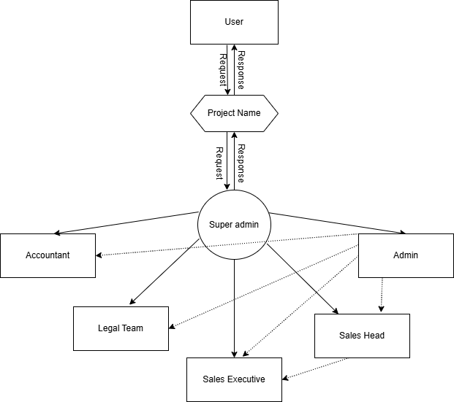

**Data Flow Diagram Level - 0**

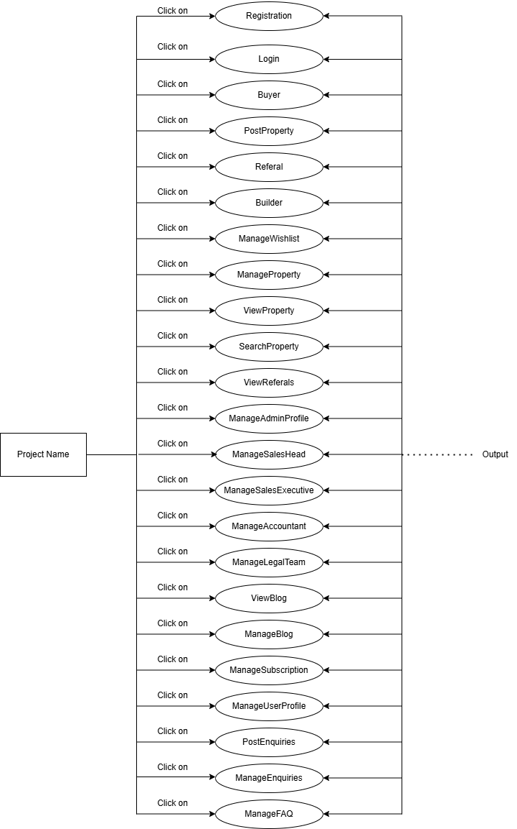

**Data Flow Diagram Level – 1**

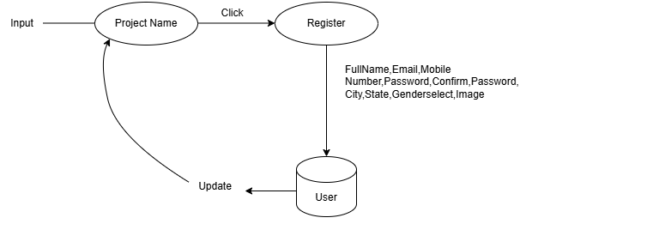

**Data Flow Diagram Level - 2 (Register User)**

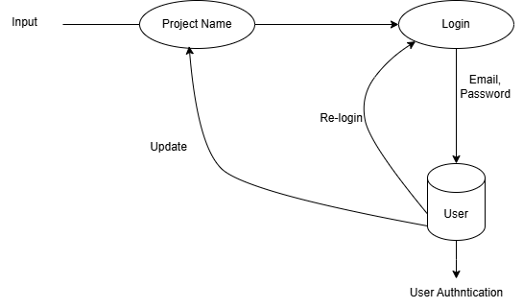

**Data Flow Diagram (Login User)**

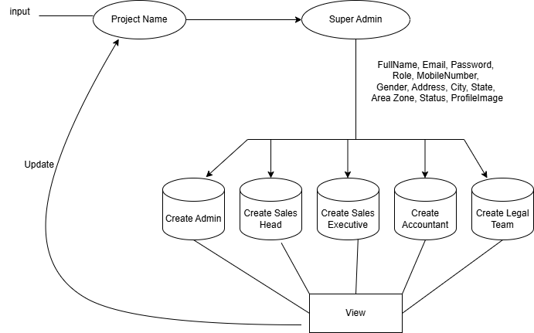

**Data Flow Diagram (Super Admin)**

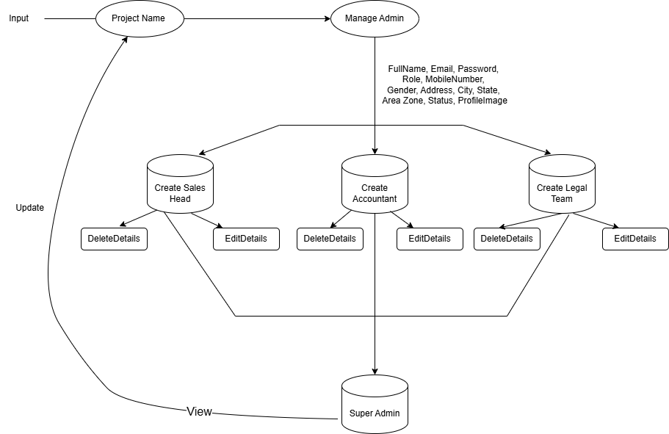

**Data Flow Diagram (Admin)**

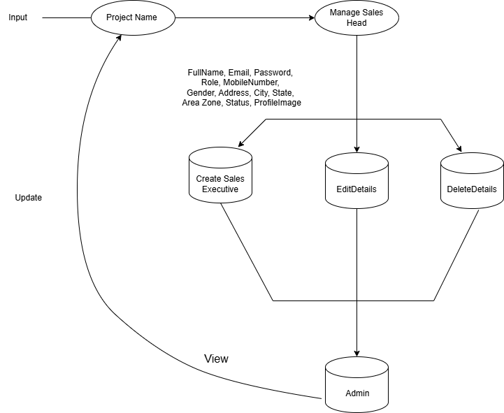

**Data Flow Diagram (Sales Head)**

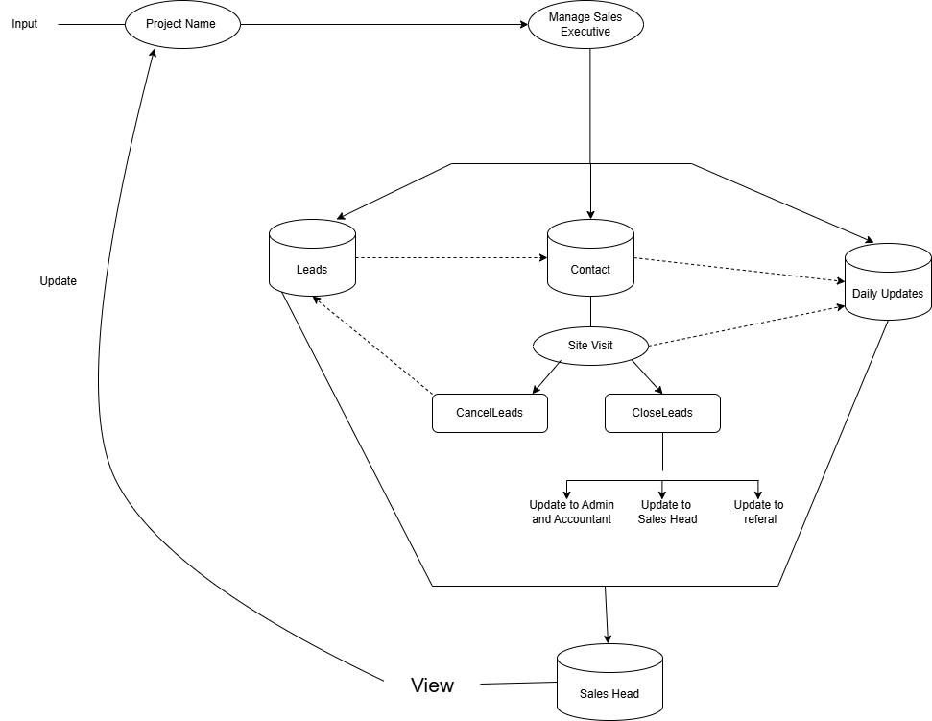

**Data Flow Diagram (Sales Executive)**

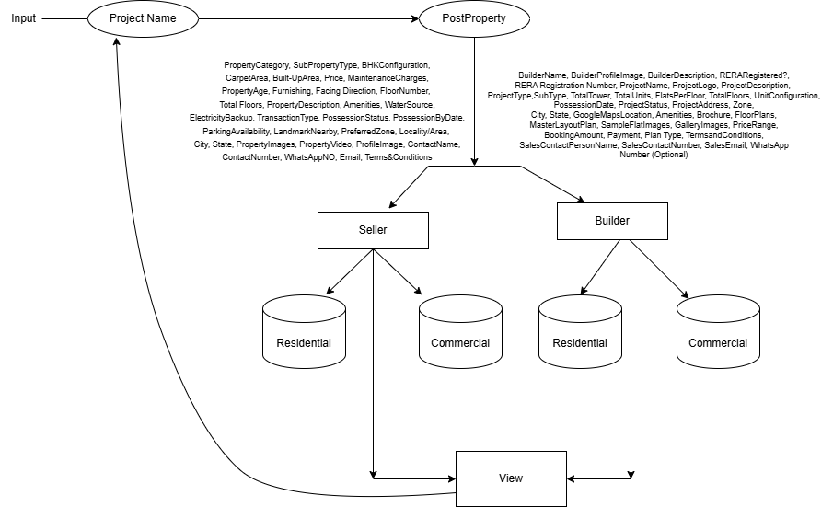

**Data Flow Diagram (Post Property)**

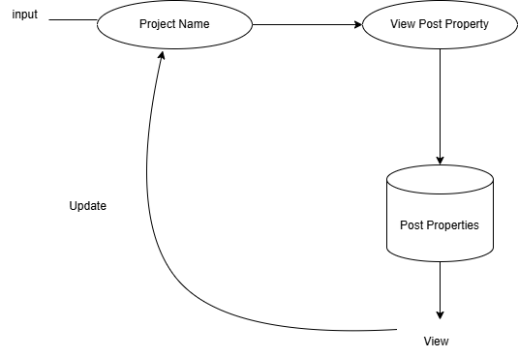

**Data Flow Diagram (View Property)**

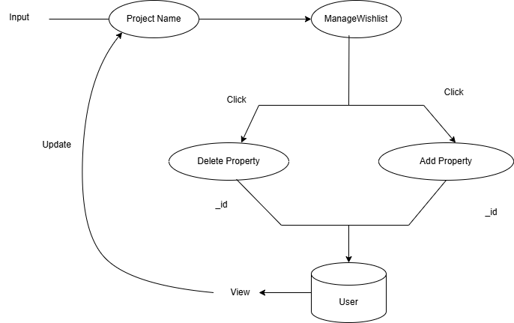

**Data Flow Diagram (Wishlist)**

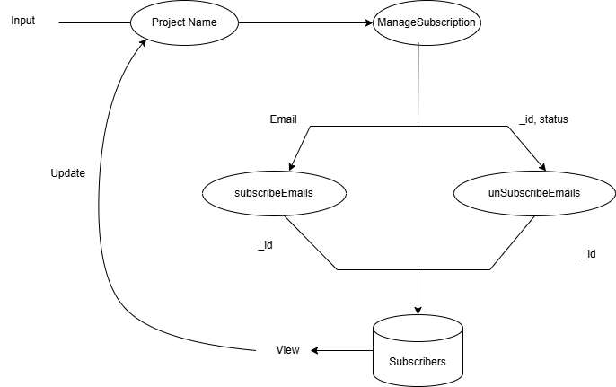

**Data Flow Diagram (Subscribe)**

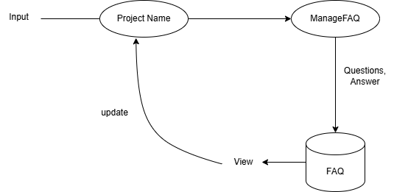

**Data Flow Diagram**

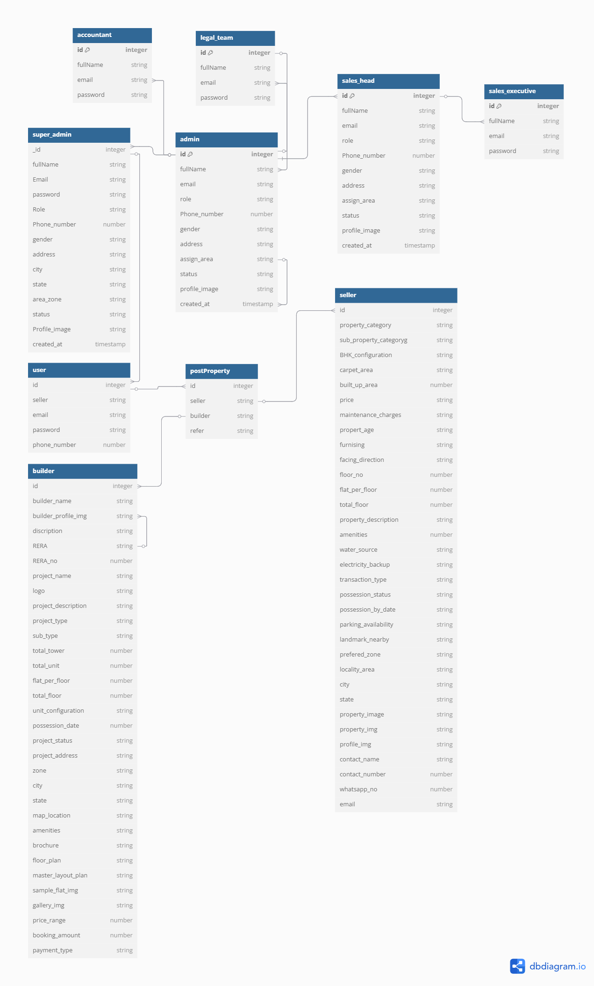**Class base diagram**

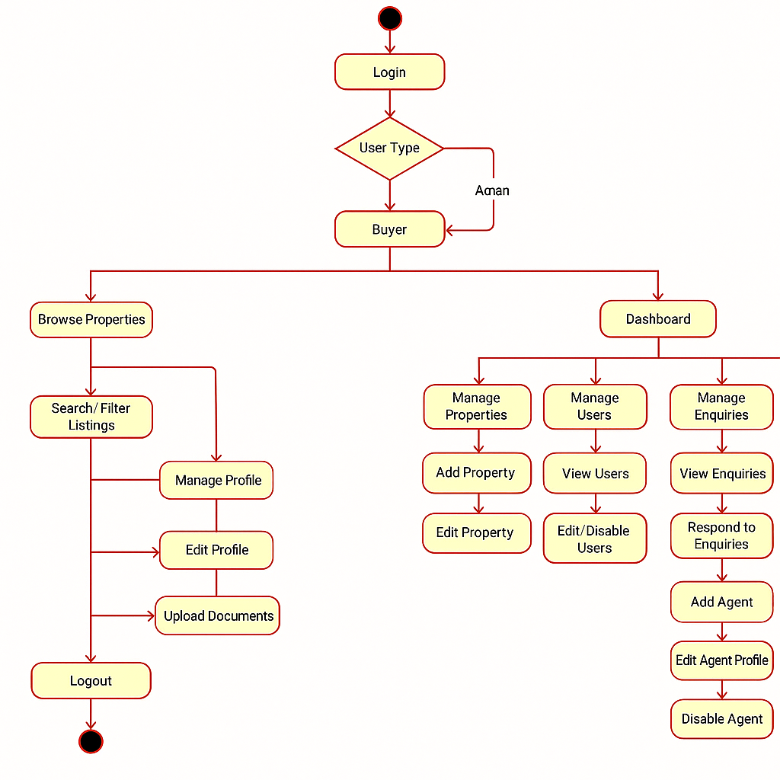

**Activity Diagram (User);**

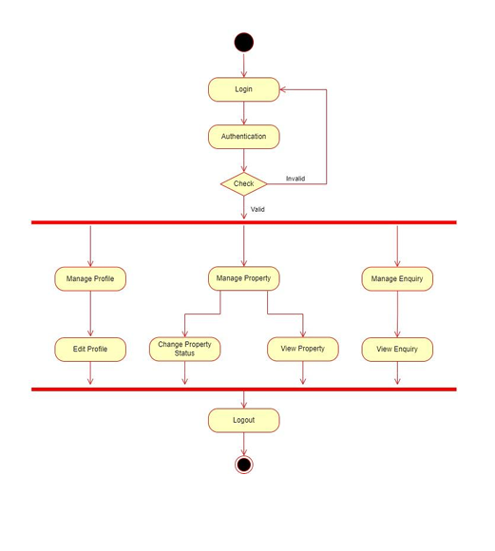

**Activity Diagram (Admin);**

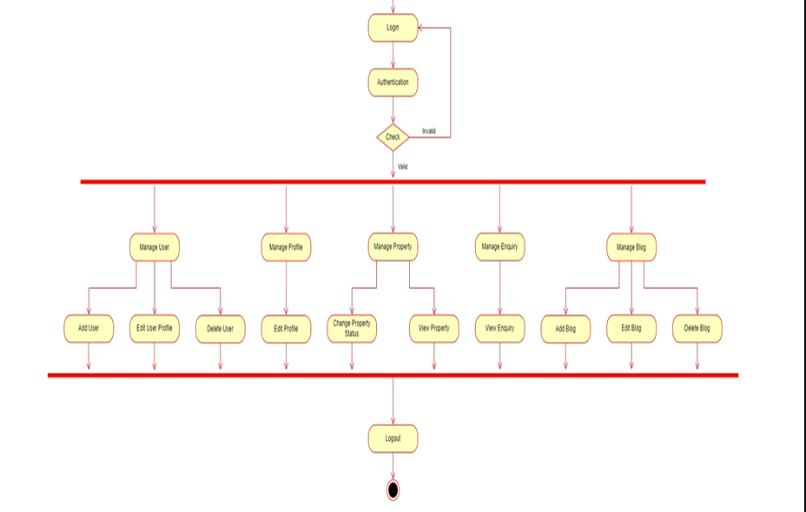

Start

**Activity diagram (Admin)**

[Login] [Registration

|

[Buyer] -----------------------------|

| |

[Post Property] [View Property]

| |

[Referral] [Search Property]

| |

[Builder]-----------------------------

|

[ManageWishlist]

|

[Manage Property]

|

[View Referrals]

|

[ManageAdminProfile] **Activity diagram**

|

[ManageSalesHead]

|

[ManageSalesExecutive]

|

[Manage Accountant]

|

[ManageLegalTeam]

|

[View Blog] --> [Manage Blog]

|

[Manage Subscription]

|

[ManageUserProfile]

|

[Post Enquiries] --> [Manage Enquiries]

|

[ManageFAQ]

**Use-Case Diagram**

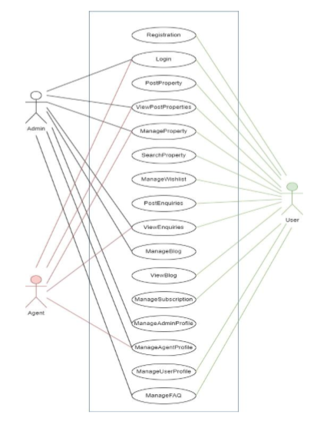

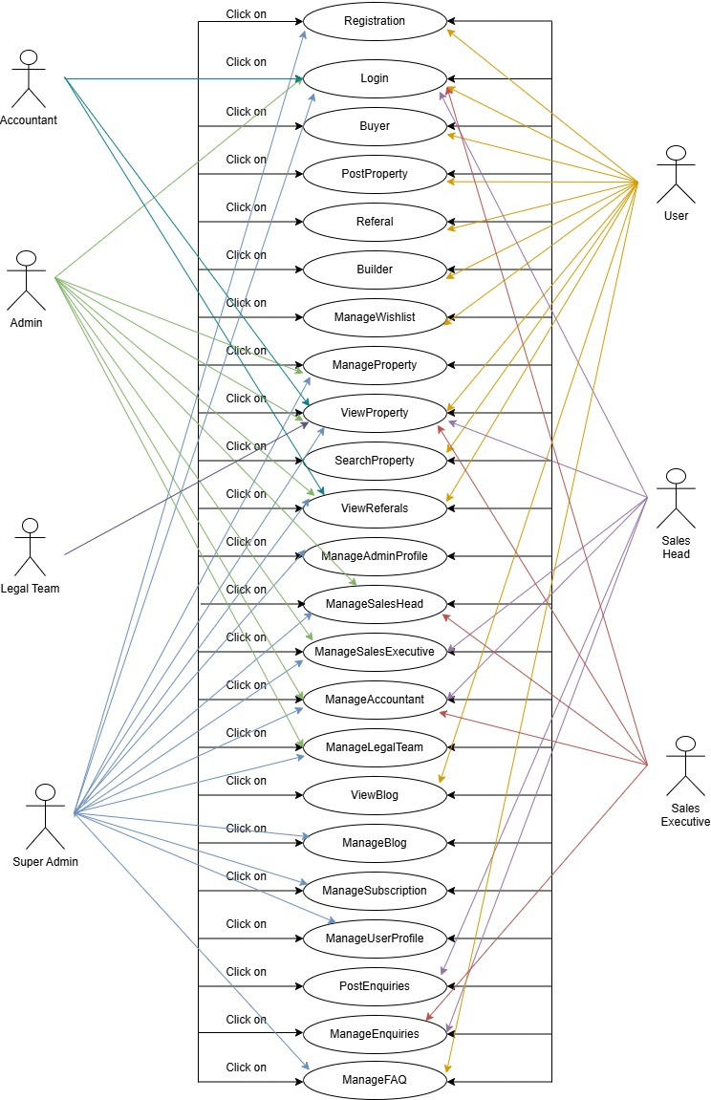

**Entity Relationship Diagram**

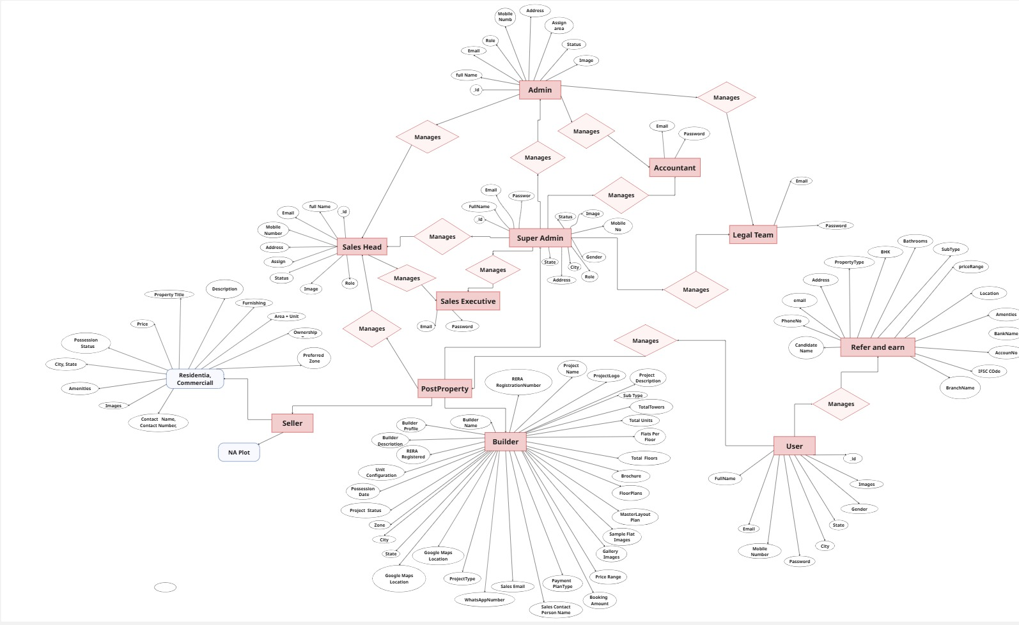

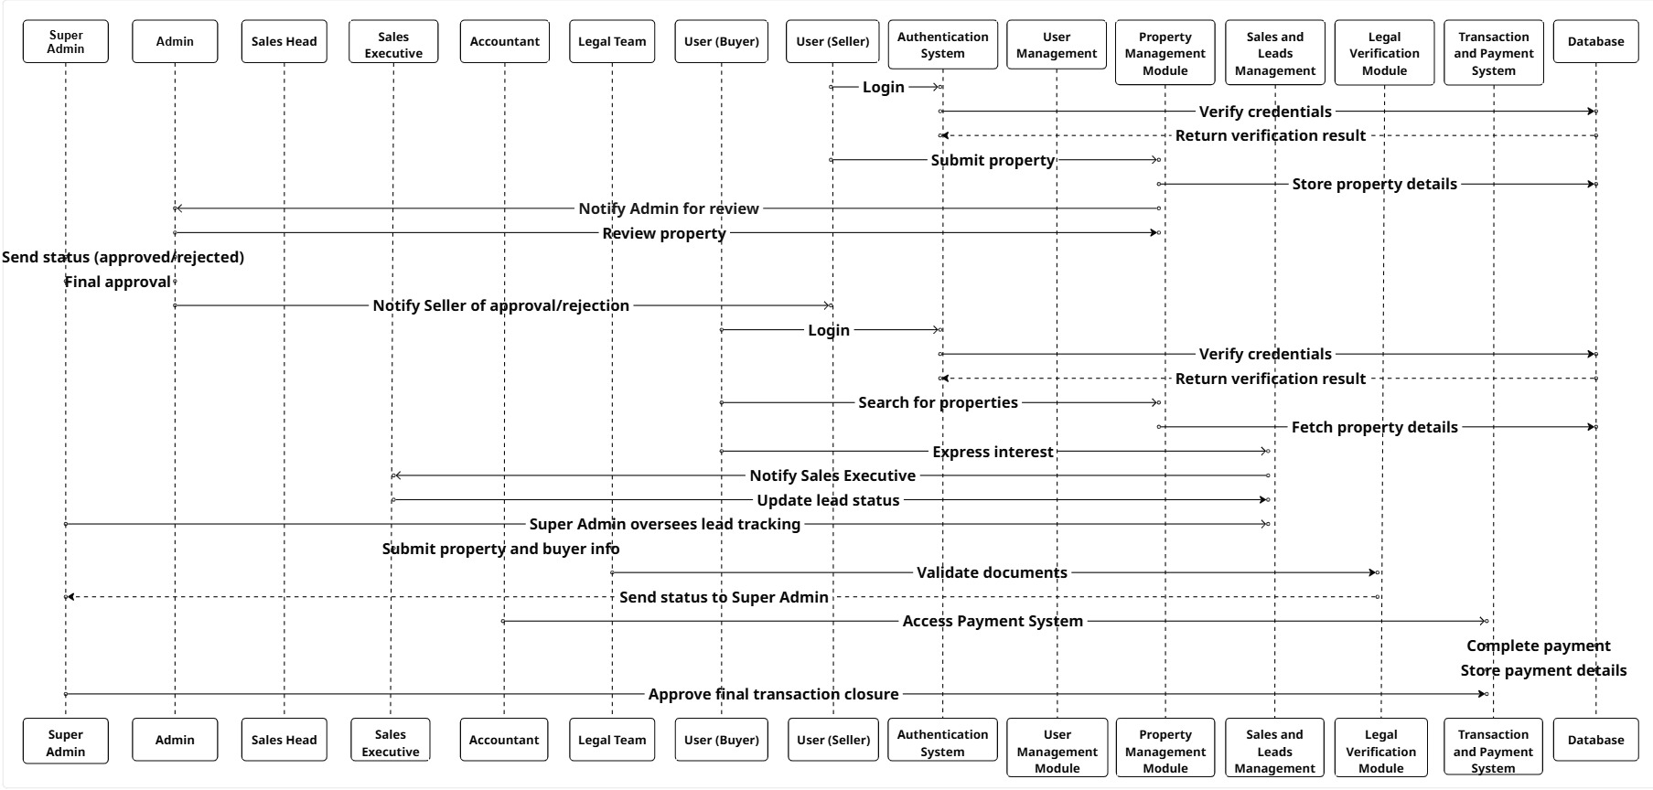

**Sequence Diagram**

**Table Structure:**

**Super Admin**

|  |  |  |
| --- | --- | --- |
| **Attributes** | **Datatype** | **Constraints** |
| _id | ObjectId | Primary Key |
| firstName | String | Not NULL |
| lastName | String | Not NULL |
| email | String | Unique |
| phoneNumber | String | Unique |
| password | String | Not NULL |
| role | String | Not NULL |
| gender | String | Optional |
| address | String | Optional |
| assignedArea | String | Optional(North/South/...) |
| status | Boolean | Default: true (active) |
| profileImage | String | Optional (URL or path) |
| createdAt | Date | Not NULL |
| updatedAt | Date | Not NULL |

**Admin**

|  |  |  |
| --- | --- | --- |
| **Attributes** | **Datatype** | **Constraints** |
| _id | ObjectId | Primary Key |
| firstName | String | Not NULL |
| lastName | String | Not NULL |
| email | String | Unique |
| phoneNumber | String | Unique |
| password | String | Not NULL |
| role | String | Not NULL |
| gender | String | Optional |
| address | String | Optional |
| assignedArea | String | Optional |
| status | String | Optional |
| profileImage | String | Optional (URL) |
| refreshToken | String | Unique |
| createdAt | Date | Not NULL |
| updatedAt | Date | Not NULL |

**User**

|  |  |  |
| --- | --- | --- |
| **Attributes** | **Datatype** | **Constraints** |
| _id | ObjectId | Primary Key |
| firstName | String | Not NULL |
| lastName | String | Not NULL |
| email | String | Unique |
| phoneNumber | String | Unique |
| password | String | Not NULL |
| role | String | Not NULL |
| createdAt | Date | Not NULL |
| updatedAt | Date | Not NULL |

**PostProperties**

|  |  |  |
| --- | --- | --- |
| **Attributes** | **Datatype** | **Constraints** |
| _id | ObjectId | Primary Key |
| propertyType | String | Not NULL |
| subPropertyType | String | Not NULL |
| selectBhk | String | Not NULL |
| carpetArea | String | Not NULL |
| builtupArea | String | Optional |
| propertyPrice | Integer | Not NULL |
| maintenanceCharges | String | Optional |
| propertyAge | String | Not NULL |
| furnishing | String | Not NULL |
| facingDirection | String | Not NULL |
| floorNumber | String | Not NULL |
| numberOfFloors | String | Not NULL |
| propertyDetails | String | Not NULL |
| perks | Array | Not NULL |
| waterSource | String | Not NULL |
| electricityBackup | String | Not NULL |
| transactionType | String | Not NULL |
| possessionStatus | String | Not NULL |
| possessionByDate | Date | Optional |
| parkingAvailability | String | Not NULL |
| landmarkNearby | String | Not NULL |

|  |  |  |
| --- | --- | --- |
| preferredZone | String | Not NULL |
| locality | String | Not NULL |
| cityName | String | Not NULL |
| state | String | Not NULL |
| propertyTitle | String | Not NULL |
| uploadPropertyImages | String | Not NULL |
| propertyVideoUrl | String | Optional |
| profileImage | String | Optional |
| contactName | String | Not NULL |
| contactNumber | String | Not NULL |
| whatsappNumber | String | Optional |
| email | String | Not NULL |
| termsAccepted | Boolean | Must be true |
| propertyPriceType | String | Not NULL |
| likes | Array | Foreign Key (Users) |
| postedBy | ObjectId | Foreign Key (Users) |
| createdAt | Date | Not NULL |
| updatedAt | Date | Not NULL |

**ResidentialProperties**

|  |  |  |
| --- | --- | --- |
| **Attributes** | **Datatype** | **Constraints** |
| propertyId | ObjectId | Primary Key |
| bhk | String | Not NULL |
| floorNo | String | Not NULL |
| totalFloors | Integer | Unique |
| bathrooms | Number | Unique |
| balconies | String | |  | | --- | | Enum (Sq.ft/Sq.m/Yards/Acres) | |
| facingDirection | String | Enum (Unfurnished, Semi, Fully) |
| builtUpArea | String | Enum (Ready, Under Construction) |
| plotArea | String | Enum (Freehold, Leasehold, Co-operative) |
| plotWidth | String | Enum (North, South, East, West) |
| plotLength | String | Not NULL |
| roomType | String | Not NULL |
| occupancyType | Array | Multi-select (from list below) |
| leaseTerm | Array | Not NULL |

**Commercial Properties**

|  |  |  |
| --- | --- | --- |
| **Attributes** | **Datatype** | **Constraints** |
| propertyId | ObjectId | Primary Key |
| carpetArea | Number | In sq.ft/sq.yds |
| builtUpArea | Number | Optional |
| cabins | Number | 1-5 |
| workstations | Number | 1-5 |
| meetingRooms | Number | 1-4 |
| powerBackup | Boolean | Yes/No |
| storageArea | Number | For Shops |
| lightingType | String | LED, CFL |
| landUse | String | Retail/Office/Mixed |
| roadAccessWidth | Number | W x L |
| ceilingHeight | Number | In ft/m |
| loadingDocks | Number | 1-4 |
| fireSafetyFeatures | Text | Optional notes |
| floorLoadCapacity | Number | |  | | --- | |  |   kg/sq.ft |
| ventilationType | String | Natural/Mechanical |
| washrooms | Number | 1-4 |
| temperatureRange | Number | Celsius |
| storageCapacity | Number | Metric Tons |
| roomCount | Number | For Hotels |
| starsRating | Number | 1 to 5 |
| banquet | Boolean | Yes/No |
| kitchenFacilities | Boolean | Yes/No |
| seatingCapacity | Number | For Cafés |
| kitchenType | String |  |
| licenseType | String | Must Agree |

**Builder**

|  |  |  |
| --- | --- | --- |
| **Attributes** | **Datatype** | **Constraints** |
| builderName | String |  |
| builderDescription | String |  |
| builderProfileImage | String | URL (Optional) |
| reraRegistered | Boolean | Yes / No |
| reraRegistrationNumber | String | Only if RERA registered |
| projectName | String |  |
| projectLogo | String | Image URL |
| projectType | String | Residential / Commercial / Mixed |
| subType | String | Based on selected type |
| launchStatus | String | New Launch / Ongoing / Completed |
| totalTowers | Number |  |
| totalUnits | Number |  |
| flatsPerFloor | Number |  |
| floorLoadCapacity | Number | |  | | --- | |  | |
| totalFloors | Number |  |
| unitConfigurations | Array |  |
| projectAddress | String |  |
| googleMapLocation | String | Optional |
| brochureFile | String | PDF |
| floorPlans | Array | File upload |
| masterLayoutPlan | String | Optional |
| sampleFlatImages | Array | Optional |
| galleryImages | Array | Multiple |
| bookingAmount | Number |  |
| priceRange | String | Food/Alcohol/etc |
| termsAndConditions | Boolean |  |

**Saleshead**

|  |  |  |
| --- | --- | --- |
| **Attributes** | **Datatype** | **Constraints** |
| name | String | NOT NULL |
| email | String | UNIQUE |
| password | String | NOT NULL |
| phoneNumber | String | Unique |
| password | String | Not NULL |
| gender (optional) | String | Optional |
| address (optional) | String | Optional |
| region | String | NOT NULL |
| status | String | Optional |
| assignedSalesHeadId | ObjectId | Optional |
| profileImage | String | Optional |
| role | String | NOT NULL |
| createdAt | Date | NOT NULL |
| updatedAt | Date | NOT NULL |

**Accountant**

|  |  |  |
| --- | --- | --- |
| **Attributes** | **Datatype** | **Constraints** |
| _id | ObjectId | Primary Key |
| name | String | Not NULL |
| email | String | Unique |
| phoneNumber | String | Unique |
| password | String | Not NULL |
| financeArea | String | Not NULL |
| role | String | Not NULL |
| createdAt | Date | Not NULL |
| updatedAt | Date | Not NULL |

**SalesExecutive**

|  |  |  |
| --- | --- | --- |
| **Attributes** | **Datatype** | **Constraints** |
| _id | ObjectId | Primary Key |
| name | String | Not NULL |
| email | String | Unique |
| phoneNumber | String | Unique |
| password | String | Not NULL |
| salesHeadId | ObjectId | Not NULL |
| target | Number | Default: 0 |
| role | String | Not NULL |
| createdAt | Date | Not NULL |
| updatedAt | Date | Not NULL |

**LegalTeam**

|  |  |  |
| --- | --- | --- |
| **Attributes** | **Datatype** | **Constraints** |
| _id | ObjectId | Primary Key |
| name | String | Not NULL |
| email | String | Unique |
| phoneNumber | String | Unique |
| password | String | Not NULL |
| specialty | String | Not NULL |
| role | String | Not NULL |
| createdAt | Date | Not NULL |
| updatedAt | Date | Not NULL |

**Blog**

|  |  |  |
| --- | --- | --- |
| **Attributes** | **Datatype** | **Constraints** |
| _id | ObjectId | Primary Key |
| title | String | Not NULL |
| description | String | Not NULL |
| category | String | Not NULL |
| numViews | Integer | NULL |
| likes | Array | Foreign Key |
| dislikes | Array | Foreign Key |
| author | String | Not NULL |
| images | Array | Not NULL |
| createdAt | Date | Not NULL |
| updatedAt | Date | Not NULL |

**Enquiries**

|  |  |  |
| --- | --- | --- |
| **Attributes** | **Datatype** | **Constraints** |
| _id | ObjectId | Primary Key |
| name | String | Not NULL |
| email | String | Not NULL |
| mobile | String | Not NULL |
| comment | String | Not NULL |
| status | String | Not NULL |
| createdAt | Date | Not NULL |
| updatedAt | Date | Not NULL |

**Categories**

|  |  |  |
| --- | --- | --- |
| **Attributes** | **Datatype** | **Constraints** |
| _id | ObjectId | Primary Key |
| cName | String | Not NULL |

**NewsLetter**

|  |  |  |
| --- | --- | --- |
| **Attributes** | **Datatype** | **Constraints** |
| _id | ObjectId | Primary Key |
| email | String | Not NULL |
| status | String | Not NULL |
| createdAt | Date | Not NULL |
| updatedAt | Date | Not NULL |

**FAQ**

|  |  |  |
| --- | --- | --- |
| **Attributes** | **Datatype** | **Constraints** |
| _id | ObjectId | Primary Key |
| userid | ObjectId | Foreign Key |
| question | String | Not NULL |
| answer | String | NULL |
| status | String | Not NULL |

**Chapter 4  
Coding**

**4.1. Algorithms:**

**1. User Registration and Authentication:**

**1.1 User Registration:**

1. Start

2. Display the registration form to the user.

3. User enters required details: name, email/phone number, password, etc.

4. Validate the input fields.

5. If any field is invalid, show an error message and ask for re-entry.

6. Check if the email/phone number is already registered.

7. If already registered, show an error message and ask for a different email/phone number.

8. Send OTP (One Time Password) to the user's email/phone number for verification using Firebase.

9. User enters the received OTP.

10. Verify the OTP.

11. If OTP is correct, proceed to the next step.

12. If OTP is incorrect, show an error message and ask for re-entry.

13. Save the user details to the database.

14. Send a confirmation email/SMS to the user.

15. End

**1.2 User Login:**

1. Start

2. Display the login form to the user.

3. User enters email/phone number and password.

4. Validate the input fields.

5. If any field is invalid, show an error message and ask for re-entry.

6. Check if the email/phone number and password match a record in the database.

7. If not, show an error message and ask for re-entry.

8. Generate a session token for the user.

9. Log the user into the system and redirect to the dashboard

10. End

**2. Property Listing:**

**2.1 Create Property Listing:**

1. Start

2. Display the property listing form to the property owner.

3. Owner enters property details: title, description, price, location, type, images, etc.

4. Validate the input fields.

5. If any field is invalid, show an error message and ask for re-entry. 6. Save the property details to the database.

7. Send a confirmation message to the owner.

8. End

**2.2 Search Property Listings:**

1. Start

2. Display the search form to the user.

3. User enters search criteria: location, property type, etc.

4. Query the database with the search criteria.

5. Retrieve and display matching property listings to the user.

6. User can refine search criteria or select a property for more details. 7. End

3. Property Interaction:

3.1 View Property Details:

1. Start

2. User selects a property from the search results.

3. Retrieve property details from the database.

4. Display property details including images, description, amenities, and owner/agent contact info.

5. End

**3.2 Contact Property Owner/Agent:**

1. Start

2. User clicks on the contact option for a property.

3. Display contact form to the user.

4. User enters message and contact details.

5. Send the message to the property owner/agent.

6. Notify the user of successful message delivery.

7. End

**3.3 Schedule Property Viewing:**

1. Start

2. User selects the option to schedule a viewing.

3. Display calendar and available time slots.

4. User selects a preferred date and time.

5. Save the viewing request to the database.

6. Notify the property owner/agent of the viewing request.

7. Send a confirmation to the user.

8. End

**4. Referral Program:**

**4.1 Refer a Property:**

1. Start

2. Display the referral form to the user.

3. User enters the contact details of the person they are referring the property to.

4. Save the referral details to the database.

5. Send a referral message/email to the referred person.

6. Notify the user of successful referral.

7. End

**4.2 Track Referral Status:**

1. Start

2. User navigates to the referral tracking section.

3. Retrieve referral status and details from the database.

4. Display referral status and potential earnings to the user.

5. End

5. Administration and Moderation:

**5.1 Manage Users:**

1. Start

2. Admin logs into the admin panel.

3. Navigate to user management section.

4. Admin can view, add, edit, or delete user accounts.

5. Save changes to the database.

6. End

**5.2 Manage Property Listings:**

1. Start

2. Admin logs into the admin panel.

3. Navigate to property management section.

4. Admin can view, approve, edit, or delete property listings.

5. Save changes to the database.

6. End

**5.3 Content Moderation:**

1. Start

2. Admin logs into the admin panel.

3. Navigate to content moderation section.

4. Admin reviews user-generated content: reviews, comments, etc.

5. Approve, edit, or delete content as necessary.

6. Save changes to the database.

7. End

**6.Reporting and Analytics:**

**6.1 Generate Reports:**

1. Start

2. Admin logs into the admin panel.

3. Navigate to the reporting section.

4. Select report type and criteria.

5. Query the database and generate the report.

6. Display the report to the admin or export as needed.

7. End

**6.2 Track Platform Metrics:**

1. Start

2. Admin logs into the admin panel.

3. Navigate to the analytics dashboard.

4. Display key metrics such as user activity, property performance, and revenue.

5. Admin can drill down into specific metrics for detailed analysis.

6. End

**Chapter 5  
 Testing**

## **Test Strategy Document**

### For Real Estate

### **1. Objective:**

To define a structured approach for testing the Real Estate E-Commerce Platform to ensure **functionality**, **usability**, **security**, **performance**, and **scalability** across all user roles and features.

### **2. Testing Scope**:

### • Functional Testing

### • User Registration and Authentication

### • Property Listing Creation and Management

### • Property Search and Discovery

### • Property Details Viewing

### • Communication and Interaction (Inquiries, Reviews, Scheduling)

### • Referral Program

### • Admin and Moderator Functions

### • Reporting and Analytics

### • Non-Functional Testing

### • Performance Testing

### • Security Testing

### • Usability Testing

### • Compatibility Testing

### • Scalability Testing

#### **Included in Scope:**

* User authentication & authorisation (Login, Role-based access)
* Property listing & search
* Admin and Super Admin dashboards
* Buyer/Seller registration and interactions
* Sales operations and lead tracking
* Accounting module (commissions, invoices)
* Referral system workflows
* Payment gateway integration
* Mobile responsiveness and cross-browser compatibility

#### **Excluded from Scope:**

* Third-party platform behaviour (e.g., Google Maps, external payment gateways)
* Manual data entry validation by external users

### **3. Testing Types:**

|  |  |
| --- | --- |
| **Test Type** | **Description** |
| **Unit Testing** | Tests individual functions/modules in isolation |
| **Integration Testing** | Ensures smooth interaction between modules |
| **System Testing** | Verifies the complete workflow across user roles |
| **Smoke Testing** | Ensures critical features (login, listing, payments) work before deeper testing |
| **Sanity Testing** | Quick validation of small feature changes or bug fixes |
| **Regression Testing** | Confirms that recent code changes didn’t break existing features |
| **User Acceptance Testing (UAT)** | End-users (buyers, sellers, admins) test to validate functionality |
| **Performance Testing** | Measures system speed under normal and peak loads |
| **Security Testing** | Identifies vulnerabilities (SQL injection, broken authentication) |

### **4. Roles & Responsibilities:**

|  |  |
| --- | --- |
| **Role** | **Responsibility** |
| **QA Lead** | Define test strategy, manage QA team, and reporting |
| **Test Engineers** | Write and execute test cases, log defects |
| **Developers** | Fix bugs, perform unit tests |
| **Project Manager** | Oversee timelines, ensure requirements alignment |
| **End Users (UAT)** | Conduct final acceptance testing and feedback |

### **5. Test Deliverables:**

* Test Plan Document
* Test Scenarios and Test Cases
* Bug/Defect Reports (with severity and priority)
* Test Execution Reports
* UAT Sign-off Document
* Traceability Matrix

### **6. Test Environment:**

|  |  |
| --- | --- |
| **Environment** | **Purpose** |
| **Development** | Used by developers for unit testing |
| **QA/Staging** | Used for integration, system, and UAT |
| **Production** | Live environment used post-deployment |

#### **Tools Used:**

* **Postman** – API testing
* **JIRA** – Bug tracking
* **Excel** – Test case management
* **Browser Stack** – Cross-browser/device testing

### **7. Test Data Strategy:**

* Use **dummy user profiles** for each role (buyer, seller, admin, super admin, referral, accountant, sales head, and sales executive).
* Simulate **realistic property listings**, lead flows, and transactions
* Include **edge case data**

### **8. Risk Management:**

|  |  |
| --- | --- |
| **Risk** | **Mitigation** |
| Missed business rules | Review with stakeholders during UAT |
| Third-party API failure | Mock/stub testing and fallback logic |
| Data loss or inconsistency | Regular backups and DB validations |
| Performance bottlenecks | Load and stress testing with JMeter or Locust |

### **9. Exit Criteria:**

Testing will be considered complete when:

* All **critical and high-severity bugs** are resolved
* At least **95% test case coverage** is achieved
* **UAT sign-off** has been received
* Final test report has been submitted

## **Test Approach**

### **1. Purpose of Test Approach:**

To define the **structured methodology** and **workflow** for planning, designing, executing, and managing testing activities. This ensures the platform meets all functional and non-functional requirements with high quality and minimal defects.

### **2. Key Testing Objectives:**

* Validate that each user role functions as expected (role-based testing)
* Ensure data integrity in transactions (buy/sell/rent)
* Confirm seamless workflow integration
* Verify scalability, security, and performance under real-world usage

### **3. Testing Levels and Scope**

#### **a. Unit Testing**

* Performed by developers
* Tests smallest functional units (e.g., login method, data validation function)
* Ensures individual components behave correctly in isolation

#### **b. Integration Testing**

* Test interactions between modules (e.g., Buyer dashboard + Property Listings)
* Validate that data flows correctly across APIs and databases
* Example: Testing if sales data correctly updates when a property is booked

#### **c**. **System Testing**

* Complete end-to-end testing across the system
* Covers core modules like: registration, search, dashboard views, payment, admin panel
* Roles tested: Buyer, Seller, Admin, Accountant, etc.

#### **d.** **User Acceptance Testing (UAT)**

* Conducted with actual end-users or product owners
* Validates real-world usability and business workflows
* Focus on user satisfaction and final approval before go-live

#### **e**. **Regression Testing**

* Re-testing after changes or enhancements
* Ensures existing features haven’t broken due to new code

#### **f.** **Smoke and Sanity Testing**

* Smoke: High-level testing to ensure critical features work before deep testing
* Sanity: Narrow testing for specific bug fixes or quick validations

### **4. Types of Testing:**

|  |  |
| --- | --- |
| **Type** | **Description** |
| **Functional Testing** | Validate UI, database, APIs, role-based access |
| **Security Testing** | Ensure data protection, session control, access rights |
| **Performance Testing** | Load, stress, and scalability testing |
| **Usability Testing** | Verify UI/UX quality and ease of use |
| **Compatibility Testing** | Test across browsers (Chrome, Firefox, Safari) and devices (mobile/tablet/laptop) |
| **Database Testing** | Verify data consistency, relationships, and backup integrity |
| **Payment Gateway Testing** | Confirm secure and accurate payment processing |
| **Referral System Testing** | Validate reward tracking, user hierarchy, and incentive accuracy |

### **5. Test Design Approach**

* **Requirement Traceability Matrix (RTM)** will map test cases to business requirements.
* **Modular Test Case Design** for each module:
  + Buyer Registration, Property Search
  + Seller Listing Management
  + Admin Controls (approvals, analytics)
  + Payment & Invoice Generation
  + Referral Agent Hierarchy & Commissions
* Use **Boundary Value Analysis**, **Equivalence Partitioning**, and **Error Guessing** techniques.

### 

### **6. Tools & Resources**

|  |  |
| --- | --- |
| **Category** | **Tools** |
| Test Management | TestRail, Excel, Jira |
| Bug Tracking | Jira. |
| Automation | Selenium, Cypress (for UI), Postman (for APIs) |
| Performance | JMeter, Locust |
| Security | OWASP ZAP, Burp Suite |
| Collaboration | Slack, GitHub, Trello |

### **7. Roles & Test Scenarios (Examples)**

|  |  |
| --- | --- |
| **Role** | **Key Scenarios** |
| **Buyer** | Sign up, search properties, send inquiry, make payment |
| **Seller** | Add/edit listings, view inquiries, communicate with buyer |
| **Admin** | Manage listings, approve users, monitor transactions |
| **Super Admin** | Configure global settings, manage all roles |
| **Sales Executive** | Track leads, follow up, assign properties |
| **Sales Head** | View team performance, generate reports |
| **Accountant** | View commissions, verify payments |
| **Referral Agent** | Track referrals, view bonus history |

### **8. Entry and Exit Criteria**

#### **Entry Criteria:**

* Finalized business requirements
* Test environment setup
* Test data available
* Unit testing completed by dev team

#### **Exit Criteria:**

* All high-severity defects fixed
* ≥ 95% test case execution
* UAT signed off
* Final test report submitted

### **9. Risk Management**

|  |  |
| --- | --- |
| **Risk** | **Mitigation** |
| Unclear business rules | Frequent meetings with domain experts |
| Tight deadlines | Prioritize smoke and critical path testing |
| Changing requirements | Use agile testing practices |
| Third-party API downtime | Implement mocks and fallback logic |

### **10. Deliverables**

* Test Plan
* Test Scenarios & Cases
* Daily/Weekly Test Reports
* Bug Reports with severity & priority
* Final Test Summary Report
* UAT Sign-Off Document
* Requirement Traceability Matrix (RTM)

**Test Types:**

### **1.** **Functional Testing**

**Purpose:**  
To verify that each function of the application works as per the business requirements.

**Includes:**

* Login/logout functionality for all roles
* Buyer: Search, filter, book, pay for properties
* Seller: Add/manage property listings
* Admin/Super Admin: Approve listings, manage users
* Referral system: Track invites, rewards
* Payment and commission flows

**Techniques Used:**  
Black box testing, use case testing, positive and negative test scenarios

### **2.** **Integration Testing**

**Purpose:**  
To test interactions between modules and ensure data flows correctly across components.

**Examples:**

* Buyer books property → triggers payment → updates seller's dashboard
* Referral signup → links to original referrer → logs in referral reports
* Sales executive updates lead status → Sales Head sees report

**Tools:**  
Postman (for APIs), JUnit

### **3. System Testing**

**Purpose:**  
To validate the complete and integrated system for compliance with requirements.

**Scope Includes:**

* End-to-end workflows: Property listing → Inquiry → Purchase → Commission
* Multi-role test: From referral → registration → sales pipeline → accounting

**Environment:**  
Staging or pre-production

### **4.** **Smoke Testing**

**Purpose:**  
To ensure the critical functionalities of the application are working after a build is deployed.

**Tested Features:**

* Application launch
* User login
* Property search
* Admin dashboard loading
* Payment initiation

If these fail, further testing is suspended until fixed.

### **5. Sanity Testing**

**Purpose:**  
To validate a particular bug fix or a new feature without doing deep testing.

**Examples:**

* Fix for broken property search → Verify search results only
* Added sorting filter for price → Check it sorts properly

Fast and focused.

### **6. Regression Testing**

**Purpose:**  
To ensure new code changes haven’t negatively impacted existing functionality.

**When to Use:**

* After updates to the referral system
* After new dashboard features are added
* After redesign of the login or search module

Automation is often applied here for efficiency

### **7. User Acceptance Testing (UAT)**

**Purpose:**  
To validate that the application meets business goals and user expectations.

**Performed By:**  
End users like sales team, admin staff, or actual buyers/sellers

**Goal:**  
Ensure workflows, forms, UI, and business rules are practical, usable, and ready for deployment.

### **8. Security Testing**

**Purpose:**  
To identify vulnerabilities and ensure secure handling of data.

**Covers:**

* Role-based access (e.g., Sales Executive cannot access Admin features)
* Session management (auto-logout, token expiry)
* Input validation (protection from XSS, SQL injection)
* Secure payment processing

### **9. Performance Testing**

**Purpose:**  
To evaluate system responsiveness and stability under various load conditions.

**Types:**

* **Load Testing:** Can the system handle 500 concurrent users browsing listings?
* **Stress Testing:** What happens if 1000 users login at once?
* **Spike Testing:** Sudden rise in users during property launches
* **Soak Testing:** How it performs over extended use (e.g., 24 hours)

**Tools:**  
Apache JMeter,

### **10. Compatibility Testing**

**Purpose:**  
To ensure the application works consistently across different:

* **Browsers:** Chrome, Firefox, Edge, Safari
* **Devices:** Mobile, tablet, desktop
* **Operating Systems:** Windows, iOS, Android

**Tools:**  
BrowserStack, CrossBrowserTesting

### **11. Database Testing**

**Purpose:**  
To verify:

* Data integrity (correct storage and retrieval)
* Relationship and constraint enforcement
* Backup and rollback operations
* Query performance

**Tests Include:**

* Does a sold property update correctly in all tables?
* Are commission logs stored accurately?

### **12. Usability Testing**

**Purpose:**  
To ensure the application is intuitive and user-friendly.

**Focus On:**

* Navigation simplicity for buyers and sellers
* Clear dashboards for Admin and Accountant
* Mobile responsiveness for sales teams
* Visual feedback on actions (loading states, success/fail messages)

**Method:**  
Task-based testing by observing actual users

### **13. Exploratory Testing**

**Purpose:**  
To uncover unexpected behaviour by manually exploring the app with minimal planning.

**Benefit:**  
Often finds hidden bugs that test cases miss (e.g., UI freezes, wrong redirection)

### **14. Recovery Testing**

**Purpose:**  
To test how the system recovers from crashes, network failures, or server restarts.

**Examples:**

* What happens if the buyer closes the browser mid-payment?
* Does the app resume after a server reboot?

**Manual Testing;** Exploratory testing to identify defects without automation.

**Automated Testing**: Use of scripts and tools to perform repetitive tests, such as regression tests.

## **Test Environment –**

### **1. Objective of the Test Environment**

The purpose of the **Test Environment** is to simulate the real-world conditions under which the platform will operate. It allows QA teams to validate the functionality, security, performance, and reliability of the application **before deployment to production**.

### **2. Components of the Test Environment**

|  |  |
| --- | --- |
| **Component** | **Description** |
| **Application Server** | Hosts the main application (front-end and back-end) |
| **Database Server** | Stores all platform data: users, listings, transactions, etc. |
| **Web Server** | Handles HTTP requests and serves web content |
| **Authentication Server** | Manages login, roles, sessions, and authorization |
| **File Storage** | Stores images, documents, and property media uploads |
| **API Services** | Connects to third-party tools (payment gateways, maps, etc.) |
| **Email Server / SMS Gateway** | For notifications, OTPs, referral alerts |
| **Analytics/Logging Tools** | Tracks events, logs bugs, and user actions |
| **Backup and Restore System** | Ensures data safety and recovery capability |

### **3. Environment Setup**

#### **Testing Environments Typically Include:**

1. **Development Environment**
   * Used by developers for initial coding and unit testing
   * May contain incomplete features or unstable versions
2. **QA / Staging Environment**
   * Replica of the production environment
   * Used by QA engineers for functional, regression, and integration testing
   * Contains real-like test data
3. **UAT Environment**
   * Used by stakeholders (sales, admin, business teams) for final acceptance testing
   * Should mirror the production system in data, roles, and access controls
4. **Production Environment**
   * Live environment where actual users interact
   * Not part of the testing cycle, but tested before launch (Smoke and Sanity)

### **4. Configuration Details**

|  |  |
| --- | --- |
| **Layer** | **Tools/Technologies** |
| **Frontend** | React.js, Angular, HTML5/CSS3 |
| **Backend** | Node.js / Django (as per tech stack) |
| **Database** | MySQL / PostgreSQL / MongoDB |
| **Server OS** | Linux (Ubuntu/CentOS) or Windows Server |
| **Web Server** | Apache / Nginx |
| **CI/CD Tools** | Jenkins, GitLab CI, GitHub Actions |
| **Test Automation Tools** | Selenium, Cypress, Postman (for API) |
| **Containerization (optional)** | Docker, Kubernetes |
| **Monitoring Tools** | Prometheus, Grafana, Logstash |

### **5. User Roles for Testing**

Each user role must be configured with appropriate permissions and test data:

|  |  |
| --- | --- |
| **Role** | **Environment Requirements** |
| **Admin** | Manage listings, view reports, and edit users |
| **Super Admin** | Access all modules and settings |
| **Buyer** | Search, shortlist, book properties |
| **Seller** | Upload/manage property details |
| **Sales Head/Executive** | Assign leads, follow up, and close sales |
| **Accountant** | View commissions, validate transactions |
| **Referral Agent** | Monitor earnings, invite new users |

### **6. Test Data Management**

* Use **realistic dummy data**: listings, users, transaction logs, referral chains
* Create **scripted data sets** for repeatable test cases
* Maintain a **data refresh strategy**: restore a clean state before each test cycle
* Isolate **sensitive or production data**

### **7. Security & Access Controls**

* Only QA engineers and authorised stakeholders should access QA/UAT environments
* Use **role-based test logins**
* Implement **IP whitelisting** or VPN access
* Disable payment gateway live mode (use test/sandbox APIs)

### **8. Environment Reset & Maintenance**

* **Regular resets** to prevent test data build-up
* **Scheduled downtimes** for patching or upgrades
* **Backup routines** to restore a clean baseline after each sprint or test cycle

### **9. Testing Activities by Environment**

|  |  |  |
| --- | --- | --- |
| **Environment** | **Purpose** | **Example Activities** |
| **Dev** | Code and unit testing | Test login module logic |
| **QA** | Full test cycle | Functional, regression, security |
| **UAT** | Final user checks | Scenario validation by real users |
| **Prod** | Go-live readiness | Final smoke tests, monitoring tools active |

### **10. Tools Used in the Test Environment:**

|  |  |
| --- | --- |
| **Area** | **Tools** |
| **Test Case Management** | Test Rail, Zephyr |
| **Bug Tracking** | Jira, Bugzilla |
| **Automation** | Selenium, Cypress, TestNG |
| **API Testing** | Postman, Swagger |
| **Performance Testing** | Apache JMeter, Locust |
| **Security Testing** | OWASP ZAP, Burp Suite |
| **Monitoring/Logs** | Kibana, New Relic, Grafana |
| **Cross-browser Testing** | BrowserStack, LambdaTest |

**Test Tools:**

**MERN-Specific Tools:**

**Unit Testing:**

• Backend (Node.js/Express): Mocha, Chai, Jest

• Frontend (React): Jest, Enzyme, React Testing Library

**Integration Testing:**

• Backend: Supertest (for API testing with Express)

• Frontend: Cypress, Selenium

• End-to-End Testing: Cypress, Selenium

**Performance Testing:**

• Artillery

• JMeter

**Security Testing:**

• OWASP ZAP

• Burp Suite

**Version Control:**

• Git

• GitHub MySpaceIndia.in 98

**CI/CD:**

• Jenkins

• GitHub Actions

• Travis CI

**Test Deliverables:**

### **1. Test Plan Document**

* **Purpose**: Outlines the test strategy, objectives, scope, resources, schedule, and responsibilities.
* **Includes**:
  + Entry/exit criteria
  + Testing types (functional, regression, security, etc.)
  + Tools used
  + Risk assessment

### **2. Test Scenarios & Test Cases**

* **Purpose**: Describe what will be tested and the steps to validate functionality.
* **Includes**:
  + Role-based test cases (e.g., login for buyer, listing for seller)
  + Expected vs. actual results
  + Priority/severity
* Format: Usually in Excel, Google Sheets, Test Rail, or Zephyr.

### **3. Requirement Traceability Matrix (RTM)**

* **Purpose**: Maps requirements to corresponding test cases to ensure full coverage.
* **Includes**:
  + Requirement ID
  + Test case ID
  + Status (Pass/Fail)
* Ensures nothing is missed in testing.

### **4. Test Data**

* **Purpose**: Structured input data used for executing test cases.
* **Includes**:
  + User data for all roles (super admin, buyer, seller, etc.)
  + Property listings, transactions, payments

### **5. Test Execution Report**

* **Purpose**: Tracks the progress of executed test cases.
* **Includes**:
  + Number of test cases passed/failed/skipped
  + Execution environment (OS, browser)
  + Screenshots for failed tests

### **6. Defect/Bug Report**

* **Purpose**: Details defects found during testing.
* **Includes**:
  + Defect ID, severity, status
  + Steps to reproduce
  + Screenshots/logs
  + Role impacted (e.g., Buyer unable to upload documents)

Tools: Jira, Bugzilla, Mantis

### **7. Test Summary Report**

* **Purpose**: Summarizes all testing efforts at the end of a cycle or release.
* **Includes**:
  + Overall test status
  + Major defects and resolutions
  + Test coverage %
  + Lessons learned

### **8. Security Test Report**

* **Purpose**: Documents vulnerabilities and security risks.
* **Includes**:
  + RBAC issues
  + SQL injection/XSS testing results
  + Recommendations

### **9. Automation Test Scripts & Results (if applicable)**

* **Purpose**: Reusable test scripts and logs from automated tests.
* **Includes**:
  + Selenium, Cypress, or API automation scripts
  + Execution reports

### **10. Test Environment Setup Document**

* **Purpose**: Ensures reproducibility of test environment.
* **Includes**:
  + OS, browser, database details
  + User roles and permissions
  + Deployment steps (if staging/UAT env)

## **Optional / Role-Based Add-ons**

|  |  |
| --- | --- |
| **Role** | **Role-specific Deliverables** |
| Super Admin | Admin permission tests, audit logs verification |
| Buyer/Seller | Usability test feedback, exploratory test logs |
| Accountant | Financial transaction test report |
| Sales Executive | CRM integration test cases |
| Sales Head | Dashboard/Reporting accuracy testing |

## **1. Super Admin**

### **Key Responsibilities:**

* Define and manage system-wide configuration and access policies.
* Create and manage roles (Admin, Buyer, Seller, etc.).
* Perform full system audits.
* Monitor activity logs and security alerts.
* Manage environment-level settings (backups, integrations, etc.).

### **Testing Responsibilities:**

* Ensure RBAC (Role-Based Access Control) is working across all modules.
* Test data visibility and restriction for lower roles.
* Validate audit trail functionalities and logs.

## **2. Admin**

### **Key Responsibilities:**

* Manage platform content and property listings.
* Approve/verify buyer or seller accounts.
* Moderate user submissions and listing accuracy.
* Oversee daily operations and support requests.

### **Testing Responsibilities:**

* Test workflows like account approval and listing verification.
* Validate admin dashboard functions and reporting.
* Check access limitations (no access to Super Admin-level features).

## **3. Buyer**

### **Key Responsibilities:**

* Register, login, and maintain their profile.
* Search and filter properties.
* Make inquiries and request site visits.
* Submit documents (e.g., loan approvals or identity proof).

### **Testing Responsibilities:**

* Functional testing of search, inquiry, document upload.
* Usability testing – navigation, filtering ease.
* Negative testing – invalid login, empty form submission.

## **4. Seller**

### **Key Responsibilities:**

* Register and list properties.
* Manage property details, images, and documents.
* Respond to buyer inquiries and schedule visits.
* Track property interest and performance.

### **Testing Responsibilities:**

* Validate listing form fields and file uploads.
* Ensure visibility to only verified buyers.
* Check that sold/rented properties update properly.

## **5. Accountant**

### **Key Responsibilities:**

* Manage financial records (payments, commissions, invoices).
* Generate transaction reports.
* Track seller payments, buyer deposits, and refunds.
* Coordinate with the sales team on commissions.

### **Testing Responsibilities:**

* Test invoice generation and payment workflows.
* Validate role restriction (can’t edit property listings).
* Perform audit testing – reports should match transactions.

## **6. Sales Head**

### **Key Responsibilities:**

* Oversee the sales team (executives).
* Assign leads and monitor sales progress.
* Analyse performance reports and KPIs.
* Interact with high-value clients.

### **Testing Responsibilities:**

* Validate lead assignment and reallocation features.
* Test reporting dashboard with correct metrics.
* Ensure visibility into all sales data but **no edit access** to property listings.

## **7. Sales Executive**

### **Key Responsibilities**:

* Follow up with assigned leads.
* Schedule site visits and update statuses.
* Coordinate with sellers for property availability.
* Log all communication with buyers.

### **Testing Responsibilities:**

* Test lead management flow (claim, update, convert).
* Ensure role cannot access financial modules.
* Confirm that data updates reflect in dashboards (for Head).

## 

## **Summary Table**

|  |  |
| --- | --- |
| **Role** | **Access Level** |
| Super Admin | Full |
| Admin | High |
| Buyer | Limited |
| Seller | Limited |
| Accountant | Moderate |
| Sales Head | Moderate |
| Sales Executive | Limited |

## **Comprehensive Testing Schedule**

### **Assumptions:**

* Project duration: ~12-16 weeks
* Testing team size: 3–5 QA engineers
* Dev follows sprint/release model (bi-weekly or monthly)
* Manual + Automation + UAT involved

### **Phase-Wise Testing Schedule**

|  |  |  |  |
| --- | --- | --- | --- |
| **Phase** | **Duration** | **Activities** | **Deliverables** |
| **1. Test Planning** | Week 1 | - Identify test scope, objectives - Assign roles/responsibilities - Select tools | Test Plan Document |
| **2. Requirement Analysis** | Week 1–2 | - Analyze BRD/FRD - Define test scenarios - RTM mapping | RTM (Requirement Traceability Matrix) |
| **3. Test Case Design** | Week 2–3 | - Write test cases per role/module - Prepare test data - Peer review | Test Cases (Excel/TestRail) |
| **4. Test Environment Setup** | Week 3 | - Setup QA/staging environments - Configure roles and access levels - Deploy latest build | Environment Setup Doc |

|  |  |  |  |
| --- | --- | --- | --- |
| **5. Unit Testing** (Dev) | Week 3–4 | - Developers test individual functions/modules | Unit Test Report |
| **6. Integration Testing** | Week 4–5 | - Validate module interaction: buyer inquiry → admin dashboard - DB/API validation | Integration Test Report |
| **7. System Testing** | Week 5–7 | - Role-based E2E scenarios: • Buyer to Seller flow • Admin approval • Sales lead tracking | Test Execution Report |
| **8. Regression Testing** | Week 6–10 (ongoing) | - Run full/partial suite after each deployment/bug fix | Regression Reports |
| **9. Performance Testing** | Week 8 | - Load test for multiple buyer/seller actions - Test report page load/response time | JMeter/Gatling Report |
| **10. Security Testing** | Week 9 | - Test RBAC (no buyer should access admin panel) - OWASP Top 10 scan | Security Test Report |
| **11. UAT (User Acceptance)** | Week 10–11 | - Real users test based on real-life scenarios - Feedback collected | UAT Feedback Form |
| **12. Bug Fix Verification** | Week 11 | - Re-test resolved defects - Close or reopen bugs | Updated Defect Report |
| **13. Test Closure** | Week 12 | - Final coverage analysis - Test summary - Lessons learned | Test Summary Report, Closure Checklist |

## **Weekly Testing Activities Breakdown**

### **Sample**: Week 5 (System Testing Focus)

|  |  |  |
| --- | --- | --- |
|  |  |  |
| |  |  |  | | --- | --- | --- | | **Day** | **Task** | **Responsible** | | Monday | Execute Buyer scenarios (search, inquiry) | QA Team A | | Tuesday | Execute Seller listing scenarios | QA Team B | | Wednesday | Admin workflows, verification flow | QA Lead | | Thursday | Sales Executive dashboard functionality | QA Team | | Friday | Bug logging & regression planning | QA Team | |  |  |

## **Role-Wise Testing Distribution (Sample)**

|  |  |  |
| --- | --- | --- |
| **Role** | **Testing Focus** | **Planned Weeks** |
| Super Admin | RBAC, logs | 5, 6, 9 |
| Admin | Workflow, dashboards | 5, 6, 10 |
| Buyer | UI/UX, property inquiry | 5–7 |
| Seller | Listing, response tracking | 5–6 |
| Accountant | Payment & report testing | 6–8 |
| Sales Head | Lead performance, dashboard | 6–8 |
| Sales Executive | Lead handling, updates | 6–8 |

## **Deliverables per Testing Week**

|  |  |
| --- | --- |
| **Week** | **Deliverables** |
| 1 | Test Plan, Roles Assignment |
| 2 | RTM, Initial Test Scenarios |
| 3 | Reviewed Test Cases, Environment Doc |
| 5–7 | Execution Logs, Daily Defect Reports |
| 8–9 | Performance & Security Reports |
| 10 | UAT Sign-Off, Final Bugs List |
| 12 | Test Summary Report, Closure Checklist |

## **Components of Risk Management**

|  |  |
| --- | --- |
| **Component** | **Description** |
| **Risk Identification** | Spotting potential threats or failure points |
| **Risk Analysis** | Assessing the likelihood and impact |
| **Risk Mitigation** | Planning strategies to reduce or avoid risks |
| **Risk Monitoring** | Continuously tracking known and emerging risks |
| **Contingency Plan** | A plan in case the risk actually occurs |

## **3. Types of Risks in Your Real Estate Project**

### **A. Project Risks**

|  |  |  |  |
| --- | --- | --- | --- |
| **Risk** | **Impact** | **Likelihood** | **Mitigation** |
| Incomplete or changing requirements | Misaligned features or rework | High | Freeze scope early, use RTM |
| Resource unavailability (QA/dev) | Delay in testing | Medium | Cross-training, buffer planning |
| Delays in environment setup | Postpone testing | High | Plan early setup, backup environments |
| Poor communication between teams | Misunderstood expectations | Medium | Daily stand-ups, shared documentation |

### **B. Technical Risks**

|  |  |  |  |
| --- | --- | --- | --- |
| **Risk** | **Impact** | **Likelihood** | **Mitigation** |
| Integration issues (e.g., buyer → admin) | System crashes or data loss | High | Frequent integration testing |
| Role-based access failure (RBAC) | Security loophole | High | Thorough security testing |
| Performance bottlenecks (search, dashboard) | Poor user experience | Medium | Load/performance testing early |
| API failures (e.g., payment, login) | Feature breakdown | Medium | API monitoring, fall-back mechanisms |

### **C. Testing Risks**

|  |  |  |  |
| --- | --- | --- | --- |
| **Risk** | **Impact** | **Likelihood** | **Mitigation** |
| Incomplete test coverage | Missed defects | High | Use RTM, peer reviews |
| Regression bugs after updates | Feature breakage | Medium | Automation + regression strategy |
| Lack of realistic test data | Inaccurate results | Medium | Generate anonymised test datasets |
| Unstable builds from dev | Test interruptions | High | Entry criteria enforcement for QA |

### **D. Security Risks**

|  |  |  |  |
| --- | --- | --- | --- |
| **Risk** | **Impact** | **Likelihood** | **Mitigation** |
| Data leaks or improper access | Legal/financial loss | High | OWASP testing, secure coding |
| Weak password policies | Account hacking | Medium | Enforce complexity rules |
| Admin-level access for lower roles | System misuse | High | Strict RBAC and audit logs |

### **E. User Acceptance Risks**

|  |  |  |  |
| --- | --- | --- | --- |
| **Risk** | **Impact** | **Likelihood** | **Mitigation** |
| End users find the system hard to use | Rework, delays in go-live | Medium | Conduct UAT early with real users |
| Misalignment with business expectations | Rejections | Medium | Demo after each sprint/release |

## 

## **4. Risk Matrix (Probability vs. Impact)**

|  |  |  |  |
| --- | --- | --- | --- |
|  | **Low Impact** | **Medium Impact** | **High Impact** |
| **Low Likelihood** | Accept | Monitor | Monitor |
| **Medium Likelihood** | Monitor | Mitigate | Mitigate |
| **High Likelihood** | Mitigate | Mitigate | Contingency Plan |

## **5. Risk Management Tools we Can Use**

* **Jira** – Create risk issues with severity, assign owners.
* **Excel / Google Sheets** – For simple risk logs with filters.
* **Risk Register Template** – Maintain a live risk register.
* **Confluence / Notion** – For collaborative updates and visibility.

|  |
| --- |
|  |
|  |
|  |
|  |

## **6. Best Practices**

* Review risks in **weekly QA status meetings**.
* Assign **owners** to each risk.
* Update **mitigation progress** regularly.
* Keep **stakeholders informed**—especially for high-impact risks.
* Involve **end users** early to reduce UAT-related risks.

## **Conclusion**

The success of a real estate software project—spanning multiple user roles such as Super Admin, Admin, Buyer, Seller, Accountant, Sales Head, and Sales Executive—relies heavily on a structured and disciplined approach to **testing and risk management**.

By implementing a clear testing schedule, defining comprehensive test deliverables, assigning precise roles and responsibilities, and proactively managing risks, your project ensures:

* **Robust functional coverage** across diverse user scenarios
* **Minimized defects and failures** in production
* **Enhanced user satisfaction** through early feedback and UAT
* **Secured data and access controls** with RBAC and audit testing
* **On-time delivery** by identifying and mitigating technical and resource-based risks

Thorough planning, regular reviews, and constant collaboration between QA, development, and business teams will not only lead to **a high-quality release**, but also establish a reliable foundation for future enhancements.

**Test Case / Test Script:**

* Super Admin
* Admin
* Buyer
* Seller
* Sales Head
* Sales Executive
* Accountant

## **1. Super Admin Test Cases**

|  |  |  |  |  |
| --- | --- | --- | --- | --- |
| **Test Case ID** | **Description** | **Precondition** | **Test Steps** | **Expected Result** |
| SA001 | Login as Super Admin | Valid credentials | Enter credentials > Login | Redirect to Super Admin dashboard |
| SA002 | Create new Admin | Logged in as Super Admin | Navigate to Admin Management > Add Admin > Fill details > Submit | Admin created successfully |
| SA003 | View all users | Logged in | Navigate to User List | List of all roles displayed |
| SA004 | Assign roles | Logged in | Assign specific roles to users | Role assignment successful |

## **2. Admin Test Cases**

|  |  |  |  |  |
| --- | --- | --- | --- | --- |
| **Test Case ID** | **Description** | **Precondition** | **Test Steps** | **Expected Result** |
| AD001 | Login as Admin | Valid credentials | Enter credentials > Login | Admin dashboard visible |
| AD002 | Manage Properties | Logged in | Add/Edit/Delete Property | Property action successful |

|  |  |  |  |  |  |  |  |  |  |  |  |  |  |  |  |  |  |  |  |
| --- | --- | --- | --- | --- | --- | --- | --- | --- | --- | --- | --- | --- | --- | --- | --- | --- | --- | --- | --- |
| |  |  |  |  |  | | --- | --- | --- | --- | --- | | **Test Case ID** | **Description** | **Precondition** | **Test Steps** | **Expected Result** | | AD003 | Manage Users | Logged in | Go to Users > View/Edit/Delete | Changes reflected | | AD004 | Generate Reports | Logged in | Navigate to Reports > Generate | Report generated/downloaded | |  |  |  |  |
|  |  |  |  |  |

## **3. Buyer Test Cases**

|  |  |  |  |  |
| --- | --- | --- | --- | --- |
| **Test Case ID** | **Description** | **Precondition** | **Test Steps** | **Expected Result** |
| BU001 | Register as Buyer | None | Fill registration form > Submit | Registration success |
| BU002 | Search Property | Logged in | Enter search criteria > Search | Matching properties shown |
| BU003 | View Property Details | Logged in | Click on property | Property detail page shown |
| BU004 | Book Site Visit | Logged in | Click "Book Visit" > Select date/time | Confirmation shown |
| BU005 | Send Inquiry | Logged in | Click "Send Inquiry" > Fill form | Inquiry sent successfully |

## **4. Seller Test Cases**

|  |  |  |  |  |
| --- | --- | --- | --- | --- |
| **Test Case ID** | **Description** | **Precondition** | **Test Steps** | **Expected Result** |
| SE001 | Register as Seller | None | Fill registration form | Seller registered |
| SE002 | Add Property | Logged in | Go to My Properties > Add Property | Property listed |
| SE003 | Edit Property | Logged in | Go to My Properties > Edit | Changes saved |
| SE004 | View Inquiries | Logged in | Go to Inquiries | Inquiry list shown |
| SE005 | Accept/Reject Buyer Interest | Logged in | Click on inquiry > Accept/Reject | Status updated |

## **5. Sales Head Test Cases**

|  |  |  |  |  |
| --- | --- | --- | --- | --- |
| **Test Case ID** | **Description** | **Precondition** | **Test Steps** | **Expected Result** |
| SH001 | View Team Performance | Logged in | Dashboard > View Reports | Team performance displayed |
| SH002 | Assign Leads | Logged in | View leads > Assign to Executive | Assignment success |
| SH003 | Monitor Conversions | Logged in | View lead status | Conversion rate shown |
| SH004 | Approve Discounts | Logged in | View request > Approve/Reject | Status updated |

## **6. Sales Executive Test Cases**

|  |  |  |  |  |
| --- | --- | --- | --- | --- |
| **Test Case ID** | **Description** | **Precondition** | **Test Steps** | **Expected Result** |
| SE001 | View Assigned Leads | Logged in | Go to Leads section | Leads list shown |
| SE002 | Update Lead Status | Logged in | Click on lead > Change status | Status saved |
| SE003 | Schedule Site Visit | Logged in | Choose property > Schedule | Visit booked |
| SE004 | Record Buyer Interaction | Logged in | Add Notes > Submit | Interaction logged |

## **7. Accountant Test Cases**

|  |  |  |  |  |
| --- | --- | --- | --- | --- |
| **Test Case ID** | **Description** | **Precondition** | **Test Steps** | **Expected Result** |
| AC001 | View Transactions | Logged in | Go to Transactions | List displayed |
| AC002 | Generate Invoice | Logged in | Choose transaction > Generate Invoice | Invoice downloaded |
| AC003 | Verify Payments | Logged in | View Payments > Mark as verified | Status updated |
| AC004 | Generate Financial Report | Logged in | Choose date range > Generate | Report available |

### Additional Test Case Categories:

* **Negative Test Cases** (e.g., invalid login, unauthorized access)
* **Security Test Cases** (role-based access control)
* **UI/UX Test Cases** (element visibility, navigation)
* **Performance Test Cases** (load time, response under load)

**Test Case 1: User Registration Accuracy Objective:**

Verify the accuracy of user registration process with valid and invalid data. Inputs: Set of valid and invalid user details (name, email, phone number, password).

Expected Outcome: The system accurately registers users with valid data and shows appropriate error messages for invalid data.

**Test Case 2: Login Functionality Objective:**

Evaluate the system's ability to authenticate users with correct and incorrect credentials.

Inputs: Correct and incorrect combinations of email/phone number and password. Expected Outcome: Users with valid credentials are successfully logged in, while users with invalid credentials receive an error message.

**Test Case 3: Property Listing Accuracy Objective**:

Verify the accuracy of property listing creation with complete and incomplete data.

Inputs: Complete and incomplete property details (title, description, price, location, images). Expected Outcome: The system accurately creates listings with complete data and shows appropriate error messages for incomplete data.

**Test Case 4: Property Search Functionality Objective:**

Assess the system's ability to search and filter properties based on user-defined criteria.

Inputs: Search criteria such as location, price range, and property type. Expected Outcome: The system returns relevant property listings that match the search criteria.

**Test Case 5: Referral System Accuracy Objective:**

Verify the accuracy of the referral system in tracking and recording property referrals. Inputs: Referral details including referee name and contact information. Expected Outcome: The system accurately records referrals and notifies the referee.

**Test Case 6: Image Upload and Display Objective:**

Verify the functionality of image upload and display in property listings. Inputs: Images of different formats and sizes. Expected Outcome: The system successfully uploads and displays images in the property listings without errors.

**Test Case 7: User Interface Usability Objective:**

Assess the usability and intuitiveness of the user interface for property browsing, listing, and referral. Inputs: Simulated user interactions with the graphical user interface. Expected Outcome: Users can easily navigate the interface, create listings, search properties, and refer properties without confusion or errors.

**Test Case 8: System Performance**

Objective: Measure the system's processing speed and response time under normal and peak loads.

Inputs: Continuous user interactions including property searches, listings, and referrals. Expected Outcome: The system performs efficiently and responds quickly without significant delays.

**Test Case 9: Data Integrity and Security Objective:**

Verify the integrity and security of user and property data. Inputs: Simulated attempts to access or modify data without proper authorization.

Expected Outcome: The system protects data integrity and prevents unauthorized access or modifications.

**Test Case 10: System Integration Objective:**

Validate the integration of the Real estate system with external services such as Firebase for OTP verification.

Inputs: User registration and login attempts requiring OTP verification. Expected Outcome: The system successfully integrates with Firebase and performs OTP verification accurately.

**Test Case 11: Mobile Responsiveness Objective:**

Assess the system's responsiveness and usability on mobile devices. Inputs: Simulated user interactions on different mobile devices and screen sizes.

Expected Outcome: The system is fully responsive and usable on mobile devices, maintaining functionality and readability.

**Test Case 12: Referral Reward Calculation Objective:**

Verify the accuracy of the referral reward calculation when a referred property is purchased. Inputs: Property purchase details including the sale price and referral information.

Expected Outcome: The system correctly calculates and credits the 1% referral reward to the referrer.

**Test Case 13: Error Handling and Alerts Objective:**

Evaluate the system's error handling and alert mechanisms. Inputs: Scenarios that trigger errors, such as server downtime or invalid user inputs.

Expected Outcome: The system handles errors gracefully and provides clear and informative alerts to the user.

**Test Case 14: Database Performance Objective:**

Measure the performance of the database under various loads. Inputs: High volume of database transactions including property listings, searches, and user registrations.

Expected Outcome: The database performs efficiently without significant slowdowns or errors.

**Test Case 15: End-to-End Workflow Testing:**

Objective: Validate the entire user workflow from registration to property purchase and referral reward. Inputs: Complete workflow steps including user registration, property listing, search, referral, and purchase.

Expected Outcome: The system successfully supports the end-to-end workflow without interruptions, accurately reflecting all steps.

**Test Case 16: System Load Testing Objective:**

Evaluate the system's stability and reliability under high loads. Inputs: Simulated high volume of concurrent users performing various operations.

Expected Outcome: The system remains stable and responsive, handling the load without crashes or significant performance degradation.

**Test Case 17: API Response Time Objective:**

Measure the response time of various APIs used in the system. Inputs: API calls for user registration, login, property listing, search, and referral.

Expected Outcome: The API response time meets the performance benchmarks, ensuring quick and efficient data exchanges.

**Test Case 18: Security Vulnerability Testing Objective:**

Identify and mitigate security vulnerabilities in the system. Inputs: Simulated security attacks such as SQL injection, XSS, and CSRF.

Expected Outcome: The system successfully mitigates security vulnerabilities, protecting user and property data from potential attacks.

**Chapter 6**

**Limitations of**

**Proposed System**

**Technical Limitations**

1. **Scalability Constraints:**

* The system may not handle high traffic or large databases efficiently without further optimisation or cloud infrastructure.
* The system may not perform well with a large number of users or property listings unless further optimised or moved to scalable cloud services.

1. **Limited Integration:**

* Difficulty integrating with third-party services like payment gateways, Google Maps, or CRM tools due to API restrictions or costs.
* Integrating external tools like payment gateways, Google Maps, or CRMs may be restricted by API limits, costs, or compatibility issues.

1. **Security Challenges:**

* Protecting user data, especially in listings and transactions, requires robust security measures that may exceed the initial scope.
* Protecting user data and transaction details requires advanced security features (encryption, authentication), which may not be fully implemented in early stages.

1. **Mobile Responsiveness:**

* Web app may have limited support for all devices or screen sizes if not designed with responsive frameworks.
* The application may not display or function correctly on all screen sizes and devices if responsive design is not fully supported.

1. **Hosting & Storage**:

* Restricted by available server resources, bandwidth, or storage depending on the hosting service.
* Limited server resources could affect the website’s performance, uptime, or ability to store large numbers of images and user data.

1. **Search & Filtering Performance:**

* Advanced search features (like geo-filters or real-time listings) might be slow or limited without powerful backend support.
* Advanced property searches and filters may become slow or unresponsive without optimised backend queries or indexing.

1. **Limited Offline Access:**

* The application may rely heavily on internet connectivity with no offline functionality.
* The platform depends on an internet connection; users cannot access or interact with features offline.

1. **Technology Stack Constraints:**

* Chosen languages, frameworks, or databases may limit future updates or integrations. The chosen programming languages or frameworks may limit flexibility for future upgrades, plugins, or platform changes.

1. **Data Management:**

* Managing a large volume of property data, user information, and referral transactions could pose challenges.

**Business Limitations:**

1. **Budget Constraints:**

**Explanation:**Limited financial resources can restrict investment in technology, design, skilled developers, third-party services (like map APIs or SMS), and marketing.

**Impact:**

* Reduced features or quality in MVP (Minimum Viable Product).
* Delayed implementation of advanced features like AI-based recommendations or analytics.

1. **Time Constraints:**

**Explanation:**Strict deadlines can lead to rushed development cycles, limiting testing, documentation, and feature richness.

Impact:

* Possible compromise on quality or performance.
* Technical debt may accumulate, requiring rework later.

1. **Regulatory and Legal Compliance:**

**Explanation:**Real estate platforms must comply with property laws, privacy regulations (like GDPR), and digital transaction laws, which can be complex and region-specific.

**Impact:**

* Legal risk if not properly addressed.
* Additional time and cost are needed to consult legal experts and implement compliant solutions.

1. **Market Competition:**

**Explanation:**Strong competition from established platforms (like Zillow, Realtor.com, MagicBricks, 99acres) makes it difficult to attract users and differentiate the product.

**Impact:**

* Requires significant investment in branding, SEO, and feature innovation.
* Pressure to match features and user experience of bigger platforms**.**

1. **User Adoption & Trust:**

**Explanation:**Users (both buyers and sellers) who are hesitant to use unfamiliar services for high-value transactions may view new platforms with scepticism.

**Impact:**

* Slow initial growth.
* Need for strong customer support, verification systems, and marketing to build trust.

1. **Limited Domain Knowledge:**

**Explanation:**Lack of real estate industry knowledge among developers or stakeholders may lead to incorrect assumptions in business logic and system design.

**Impact:**

* Misalignment between system functionality and real-world real estate practices.
* Additional effort needed for market research and consultations.

**7. Dependency on External Partners:**

**Explanation:**  
Reliance on agents, builders, photographers, or third-party verification services can cause delays or inconsistencies in content and service quality.

**Impact:**

* Inconsistent listings or delays in property approval.
* Risk of poor user experience due to unreliable external support.

**8. Maintenance and Operational Costs:**

**Explanation:**Even after deployment, ongoing costs for hosting, maintenance, customer service, and feature updates can strain business resources.

**Impact:**

* Difficult to sustain the platform without a clear monetisation strategy.
* Potential disruption if not budgeted for long-term operations.

**9. Reliance on Referrals:**

* The success of the referral program hinges on user engagement and convincing them to actively promote properties.

**10. Sustainability of Referral Commissions:**

* Offering a 1% commission on sales could strain profit margins, especially for high-value properties.

## **Operational Limitations**

1. **Manual Data Entry and Listing Management:**

**Explanation:**If property listings are manually entered or updated by agents or admins, it increases the chances of errors, outdated information, and inconsistency.

**Impact:**

* Time-consuming and labour-intensive.
* Risk of user dissatisfaction due to inaccurate or old listings

1. **Customer Support Limitations:**

**Explanation:**Providing round-the-clock support for users (buyers, sellers, and agents) requires trained staff and tools like chatbots or ticketing systems, which may not be in place.

**Impact:**

* Delays in response can lead to loss of trust.
* High support load during peak times or platform issues.

1. **User Verification and Fraud Prevention:**

**Explanation:**Ensuring that listed properties and users are legitimate requires verification steps (e.g., document checks, phone/email confirmation), which may be incomplete or inefficient.

**Impact:**

* Increased risk of fake listings, scams, or fraudulent users.
* Legal or reputational damage if fraud occurs on the platform.

1. **Platform Downtime and Maintenance:**

**Explanation:**Scheduled maintenance or unexpected downtimes can interrupt access to the platform for users and agents.

**Impact:**

* Loss of business during peak hours.
* Damaged credibility if frequent or unplanned.

1. **Training and Onboarding of Agents/Partners:**

**Explanation:**Real estate agents or partners may not be tech-savvy, requiring regular training and onboarding to use the platform effectively.

**Impact:**

* Slower adoption of system features.
* Need for extra resources to assist partners regularly.

1. **Content Moderation:**

**Explanation:**Monitoring images, descriptions, and comments for inappropriate or misleading content requires either manual oversight or automated moderation tools.

**Impact:**

* High operational workload.
* Legal and trust issues if inappropriate content is not addressed quickly.

1. **System Performance Monitoring:**

**Explanation:**Continuous monitoring for bugs, slow loading times, and server errors is needed, but may be underdeveloped in early stages.

**Impact:**

* Delayed issue detection.
* Poor user experience due to unresolved performance problems.

1. **Payment and Transaction Disputes:**

**Explanation:**If the platform includes booking fees, subscriptions, or escrow services, handling payment failures and disputes becomes complex.

**Impact:**

* Operational overhead in resolving issues.
* Risk of customer complaints or legal actions if not handled promptly.

1. **Dependency on Internet and Infrastructure:**

**Explanation:  
The platform’s usability is dependent on stable internet access and device compatibility for both users and admins.**

**Impact:**

* Limited access in rural or underdeveloped areas.
* Poor user experience on older devices or slow networks.

1. **Dispute Resolution:**

* The platform might need robust mechanisms to handle disputes arising between buyers and sellers during transactions.

1. **Regulation Compliance:**

* Navigating and complying with real estate regulations across various Indian states could be complex.

1. **Limited Functionality:**

* The project currently lacks features like payment gateways and chat systems, hindering a smooth transaction process.

**Additional Limitations**

1. **User Experience (UX) Constraints:**

**Explanation:**Designing an intuitive, easy-to-navigate interface that satisfies both tech-savvy and non-technical users is a challenge. Poor UX can lead to high bounce rates and low conversions.

**Impact:**

* Users may abandon the platform quickly.
* More investment is needed in usability testing and redesign

1. **Localisation and Language Barriers:**

**Explanation:**If the platform targets multiple regions or countries, it must support multiple languages, currencies, and cultural formats (like address or date formats).

**Impact:**

* Increases complexity and development effort.
* Risk of alienating non-English-speaking users if not properly localised.

1. **Real-Time Data Limitations:**

**Explanation:**Providing real-time data on property availability, pricing, and location trends may be difficult without integrations with government/property databases.

**Impact:**

* Users might see outdated or incorrect information.
* Trust and credibility can decline if data is unreliable.

1. **User Device Compatibility:**

**Explanation:**Users may access the platform using various devices and browsers. Ensuring compatibility across all platforms (Windows, Android, iOS, Chrome, Safari, etc.) can be difficult.

**Impact:**

* The platform may not work or display properly on some devices.
* Increased development time for cross-platform testing.

1. **Digital Literacy Gap:**

**Explanation:**Some target users (especially property owners or older clients) may lack digital literacy to use online platforms effectively.

**Impact:**

* The platform may not reach all intended users.
* Requires simpler UI, tutorials, or even offline onboarding support.

1. **Dependence on Accurate User Input:**

**Explanation:**Property data (price, area, amenities, location) is often entered by users. If not verified, inaccurate data can degrade platform quality.

**Impact:**

* Misinformation leads to a poor user experience.
* Requires human moderation or automated validation.

1. **Environmental and Legal Disruptions:**

**Explanation:**Changes in real estate laws, property tax structures, or environmental policies can impact platform functionality or compliance unexpectedly.

**Impact:**

* May require quick code or policy updates.
* Legal risks if non-compliance persists.

1. **Lack of Monetisation Clarity:**

**Explanation:**If there’s no clear revenue model (e.g., commissions, ads, subscriptions), the platform might struggle to sustain itself financially.

**Impact:**

* Long-term viability is at risk.
* Difficult to attract investors or partners.

1. **SEO and Digital Marketing Challenges:**

**Explanation:**Ranking well in search engines and attracting users through digital marketing requires time, effort, and expertise.

**Impact:**

* Slow organic growth.
* Need for dedicated SEO/marketing budget and team.

1. **Climate or Season-Dependent Usage:**

**Explanation:**Real estate activity can vary by season or location (e.g., monsoons slowing site visits or holidays affecting demand).

**Impact:**

* Fluctuating user traffic and listing activity.
* Requires planning for off-season marketing and incentives.

1. **Dependence on Internet Connectivity:**

* Users in areas with poor internet access might be excluded from fully utilising the platform.

1. **Potential for Bias:**

* The referral system could incentivise users to promote properties with higher commissions, potentially skewing search results.

1. **Lack of User Reviews for Sellers:**

* Without seller reviews, it might be challenging for buyers to assess seller credibility.

**Chapter 7**

**Proposed**

**Enhancement**

**Addressing Technical Limitations:**

1. **Enhancing Scalability with Cloud Infrastructure:**

**Limitation Addressed: Scalability Constraints**

**Enhancement:**

* Use **cloud services** like AWS, Google Cloud, or Azure to enable auto-scaling based on user demand.
* Implement **microservices architecture** to scale independently.

**Benefits:**

* + - Handles more traffic and listings without performance issues.
    - Reduces server crashes during peak usage.

1. **Implementing Robust API Management:**

**Limitation Addressed:** Limited Integration  
**Enhancement:**

* Use an **API Gateway** (like Amazon API Gateway) to manage, throttle, and monitor third-party API usage.
* Build **modular integration layers** to allow future API additions with minimal code change.

**Benefits:**

* Reliable and scalable third-party integrations (e.g., Google Maps, payment gateways).
* Avoids system breakdown due to external API limits.

1. **Strengthening Security Architecture:**

**Limitation Addressed:** Security Challenges  
**Enhancement:**

* Implement **OAuth 2.0 / JWT-based authentication**, role-based access control, and **end-to-end encryption**.
* Apply **regular security audits**, input sanitisation, and protection against XSS/SQL injection.

**Benefits:**

* Secures user data and builds trust.
* Prevents unauthorised access and data leaks.

1. **Responsive and Adaptive UI Frameworks:**

**Limitation Addressed:** Mobile Responsiveness  
**Enhancement:**

* Use **responsive design frameworks** like Tailwind CSS or React for cross-device compatibility.
* Test UI with tools like **BrowserStack** to cover multiple screen sizes and resolutions.

**Benefits:**

* Seamless experience on mobile, tablet, and desktop.
* Increases user engagement and accessibility.

1. **Cloud-Based Storage & CDN Usage:**

**Limitation Addressed:** Hosting & Storage  
**Enhancement:**

* Use **Amazon S3**, **Firebase Storage**, or **Google Cloud Storage** for media files.
* Use **CDNs (Content Delivery Networks)** like Cloudflare to serve images and assets faster.

**Benefits:**

* Reduces server load.
* Speeds up content delivery and improves uptime.

1. **Advanced Search Optimisation Techniques:**

**Limitation Addressed:** Search & Filtering Performance  
**Enhancement:**

* Implement **Elasticsearch** or **Algolia** for high-speed and intelligent search results.
* Optimize backend queries using indexes, caching and pagination.

**Benefits:**

* Faster and more relevant property search results.
* Improved performance under heavy load.

1. **Offline-First Capabilities via PWA:**

**Limitation Addressed:** Limited Offline Access  
**Enhancement:**

* Convert the platform into a **Progressive Web App (PWA)** to allow offline access to previously visited pages.
* Cache data locally using **service workers** and **localStorage**.

**Benefits:**

* Improves usability in low-connectivity areas.
* Enhances mobile experience.

1. **Future-Proof Technology Stack:**

**Limitation Addressed:** Technology Stack Constraints  
**Enhancement:**

* Choose widely adopted, modular, and well-documented frameworks (e.g., React, Node.js, Django).
* Keep libraries and dependencies updated with **CI/CD pipelines** and version control tools.

**Benefits:**

* Easier to maintain and upgrade over time.
* Ensures long-term support and developer availability.

**Enhancing User Adoption and Retention:**

**1. User-Centric Onboarding Experience:**

**Purpose:** Help new users (buyers, sellers, agents) quickly understand and benefit

from the platform.

**Enhancement:**

* Implement **guided onboarding** with tooltips, walkthroughs, or interactive tutorials.
* Provide quick-start options like “List Property in 3 Steps” or “Search Nearby Homes Instantly.”
* Offer demo accounts or sandbox mode for agents.

**Impact:**

* Reduces learning curve for new users.
* Increases initial engagement and conversion.

**2. Personalized User Experience:**

**Purpose**: Make users feel the platform is tailored to their needs.

**Enhancement:**

* Use **behaviour-based recommendations** (e.g., “Similar homes you might like”).
* Allow users to **save searches**, favourite listings, and receive **alerts** for new properties.

**Impact:**

* Keeps users coming back for relevant content.
* Improves satisfaction and time-on-site.

**3. Mobile App Development:**

**Purpose:** Capture and retain users who prefer mobile browsing or app usage.

**Enhancement:**

* Launch a **dedicated mobile app** (iOS/Android) with push notifications and offline browsing.
* Optimize for low-bandwidth conditions, especially for emerging markets.

**Impact:**

* Increases daily active users.
* Enhances accessibility and retention.

**4. Gamification and Loyalty Programs:**

**Purpose:** Make using the platform fun and rewarding.

**Enhancement:**

* Reward agents for verified listings or fast responses with **badges or rankings**.
* Provide **points or credits** to users for referrals, reviews, or repeated use.

**Impact:**

* Encourages user activity and loyalty.
* Builds a sense of community and competition.

**5. Trust-Building Features:**

**Purpose:** Reduce hesitation in using or returning to the platform.

**Enhancement:**

* Add **user reviews**, **verified agent badges**, and **property verification labels**.
* Display **secure payment and data handling** notices.

**Impact:**

* Builds confidence in listings and transactions.
* Improves platform reputation and credibility.

**6. Effective Email & Push Notification Strategy:**

**Purpose:** Keep users engaged even when they’re not actively visiting.

**Enhancement:**

* Send **personalized notifications** about saved search updates, price drops, or nearby listings.
* Use **automated email workflows** for onboarding, re-engagement, and promotions.

**Impact:**

* Increases return visits.
* Keeps users informed and involved.

**7. Community Engagement and Support:**

**Purpose:** Make users feel heard and valued.

**Enhancement:**

* Provide **live chat** or **community forums** for questions and discussions.
* Actively seek user feedback and feature requests through surveys or polls.

**Impact:**

* Builds long-term relationships.
* Encourages word-of-mouth promotion.

**8. Social Media and Influencer Integration:**

**Purpose:** Extend reach and social proof.

**Enhancements:**

* Allow easy **social sharing of listings** and user achievements (e.g., "My first listed property!").
* Collaborate with **real estate influencers or local agents** for exposure.

**Impact:**

* Drives organic traffic.
* Improves user trust through peer influence.

**9. Consistent UX and Performance Optimisation:**

**Purpose:** Retain users by providing a smooth experience.

**Enhancements:**

* Reduce page load time, especially on listing detail pages.
* Ensure **bug-free, consistent navigation** across devices and sessions.

**Impact:**

* Reduces drop-off rates.
* Improves satisfaction and return rate.

**10. Analytics-Driven Improvements:**

**Purpose:** Continuously adapt the platform to user behaviour**.**

**Enhancement:**

* Use **tools like Google Analytics, Mixpanel, or Hotjar** to monitor user activity.
* A/B test new features and content to see what retains users best.

**Impact:**

* Makes data-backed decisions.
* Helps tailor the platform to user preferences over time.

**Optimizing the Referral Program:**

1. **Define Clear Objectives and Target Audience:**

**Purpose:** Ensure the program aligns with your growth strategy.

**Enhancement:**

* Decide whether the referral program aims to attract **buyers, sellers, Accountant , sales head , sales executive , admin and super admin** .
* Align rewards with user behaviour (e.g., more for verified listings or property closings).

**Impact:**

* Higher relevance and participation.
* Better quality of referred users.

1. **Create a Simple, Transparent Referral Process:**

**Purpose:** Make it easy for users to refer others and understand what they get.

**Enhancement:**

* Use a **unique referral code or link** for each user.
* Show a **step-by-step breakdown** of how the referral works (e.g., “Invite → Sign-up → Reward”).

**Impact:**

* Increases participation and trust.
* Reduces confusion or misuse.

1. **Offer Tiered or Dual Incentives:**

**Purpose:** Encourage both the referrer and the referee to participate.  
**Enhancement**:

* Give **both parties a reward** (e.g., ₹200 credit for the referrer and ₹100 for the new user).
* Implement **tiered rewards** (e.g., refer 5 users and get bonus cash or premium listing features).

**Impact**:

* Boosts viral growth.
* Encourages repeated referrals.

1. **Integrate Referral Program Seamlessly into the UI:**

**Purpose:** Make the feature discoverable and frictionless.

**Enhancement:**

* Add a **referral tab** in the user dashboard.
* Include sharing options (WhatsApp, Facebook, Email) and track referrals in real time.

**Impact:**

* Promotes active sharing.
* Reduces user drop-off during the referral process.

1. **Track and Monitor Referral Quality:**

**Purpose:** Avoid fake or low-quality referrals.  
**Enhancement**:

* Set conditions like “reward only when the referee verifies account” or “completes a listing/search.”
* Use **fraud detection logic** to flag suspicious activity (e.g., multiple referrals from same IP/device).

**Impact**:

* + - Maintains platform integrity.
    - Reduces reward abuse.

1. **Provide Reward Flexibility:**

**Purpose:** Let users choose how they want to benefit.

**Enhancement:**

* Offer **multiple reward types**: wallet credit, discounts on premium services, priority listing boosts, or vouchers.
* Allow users to **donate their referral reward** (for goodwill or PR).

**Impact:**

* Appeals to a wider user base.
* Encourages repeated use.

1. **Showcase Social Proof and Gamification:**

**Purpose:** Make referrals competitive and rewarding.

**Enhancement:**

* Show **leaderboards** (e.g., “Top Referrers of the Month”).
* Use **badges, ranks**, or even certificates for agents/users with high referrals.

**Impact:**

* Encourages ongoing engagement.
* Builds community status and loyalty.

**8. Automate Notifications and Tracking:  
 Purpose:** Keep users informed about their referral status and rewards.  
 **Enhancements**:

* Send **automated emails or push notifications** at every stage (“Your friend joined!” “You earned ₹100!”).
* Display referral status in the user dashboard with timestamps and reward breakdown.

**Impact:**

* Increases transparency and motivation.
* Reduces support requests.

**9. Promote the Referral Program Strategically:  
 Purpose:** Maximize reach and awareness.  
 **Enhancement**:

* Highlight the referral program on your homepage, app banners, and during onboarding.
* Run **limited-time referral contests** (e.g., “Refer 3 users by this Friday and win a bonus!”).

**Impact:**

* Increases visibility and engagement.
* Spurs quick growth via urgency.

**10. Measure Performance and Iterate:  
 Purpose:** Continuously improve the program based on data.  
 **Enhancement**:

* Track **referral conversion rate**, **cost per acquired user**, and **LTV (lifetime value)** of referred users.
* Use A/B testing to refine rewards, messages, and referral flows.

**Impact**:

* Ensures long-term effectiveness.
* Adapts to user behaviour and market trends.

## **Expanding Functionality and User Experience:**

1. **Advanced Property Search and Filters:**

**Purpose:** Help users find exactly what they need with minimal effort.

**Enhancement:**

* Add **multi-criteria filters**: price range, location radius, amenities, property type, floor plan, furnishing.
* Enable **map-based search** with geolocation and drawing tools.
* Offer **voice search** and “near me” options.

**Impact:**

* Increases user satisfaction and engagement.
* Reduces bounce rate by helping users find relevant listings faster.

1. **Interactive Property Listings:**

**Purpose:** Make listings more informative and visually engaging.

**Enhancement:**

* Add **3D virtual tours**, **360° images**, and **video walkthroughs**.
* Include **interactive floor plans** where users can click rooms to see details.
* Add **property comparison tools** for side-by-side comparisons.

**Impact:**

* Builds trust in listings.
* Increases user time-on-site and conversion.

1. **Smart Recommendation Engine:**

**Purpose:** Deliver personalized suggestions based on user behaviour.

**Enhancements:**

* Use **machine learning** to analyse user preferences and recommend properties.
* Show “Similar Listings” or “People also viewed…” features.
* Offer **AI-powered investment suggestions** based on trends.

**Impact:**

* Enhances personalization.
* Encourages repeat visits and long-term engagement.

1. **Agent and Owner Profiles with Ratings:  
   Purpose:** Build trust and transparency in transactions.

**Enhancements:**

* Allow verified agents/owners to have detailed profiles, listing history, and contact details.
* Enable **user reviews and ratings** based on communication, honesty, and accuracy.
* Display **“Verified by Platform”** badges for credibility.

**Impact:**

* Increases trust and accountability.
* Helps users choose reliable contacts.

1. **Chat and Appointment Booking System:**

**Purpose:** Improve communication between users and agents.

**Enhancements:**

* Integrate **in-app messaging/chat** with message templates and attachment support.
* Add **calendar booking** for property visits with reminders and sync with Google Calendar.
* Include **auto-replies** and **agent availability indicators.**

**Impact:**

* Reduces friction in lead follow-up.
* Improves response time and user experience.

1. **Save, Share, and Alerts Functionality:**

**Purpose:** Enable ongoing interaction with the platform.

**Enhancements:**

* Let users **save listings**, **create shortlists**, and **set alerts** for similar properties or price drops.
* Add easy **sharing options** via WhatsApp, email, and social media.
* Include **change tracking** (e.g., “This property’s price dropped by ₹50,000”).

**Impact:**

* Encourages repeat visits.
* Helps users keep track of changing market options.

1. **Localized Content and Multilingual Support:**

**Purpose:** Cater to a diverse user base from various regions.

**Enhancement:**

* Offer the platform in **multiple Indian/local languages**.
* Customize content based on location
* Provide **currency conversion** if targeting NRI buyers.

**Impact:**

* Makes the platform inclusive and widely usable.
* Improves SEO and engagement across regions.

1. **Integrated Loan, EMI & Legal Services:**

**Purpose:** Become a one-stop shop for the home-buying journey.

**Enhancements:**

* Integrate **loan eligibility calculators** and **EMI tools**.
* Partner with banks and legal consultants for **loan applications** and **property verification**.
* Provide **in-app documentation support** for buyers and sellers.

**Impact:**

* Increases platform value.
* Builds user loyalty by addressing the full buying cycle.

1. **Real-Time Notifications and Activity Feed:**

**Purpose:** Keep users updated and engaged.

**Enhancements:**

* Push or email **notifications** for new listings, saved searches, messages, or promotions.
* Display a **personalized activity feed**: “New listings in your area,” “Agent replied,” etc.
* Add a **notifications center** on the dashboard.

**Impact:**

* Increases user return rate.
* Drives interaction without users needing to actively search.

**10. User Dashboard and Analytics:  
 Purpose:** Give users control and insight over their activity.  
 **Enhancement**:

* Buyers can track saved listings, alerts, and inquiries.
* Sellers and agents can view **analytics** like views, leads, and conversions.
* Include **listing performance graphs**, tips for improvement, and suggestions.

**Impact:**

* Empowers users to act strategically.
* Encourages platform stickiness and professionalism.

**11. Mobile-First, Progressive Web App (PWA) Experience:  
 Purpose:** Optimize for mobile users with offline capabilities.  
 **Enhancement**:

* Ensure full mobile compatibility across browsers and screen sizes.
* Use **PWA technology** to allow users to use the platform offline and get push notifications.
* Optimize image and video loading speeds with compression.

**Impact**:

* Enhances experience for mobile-first users.
* Supports rural and low-bandwidth environments.

**12. Gamification and User Milestones:  
 Purpose:** Increase engagement through motivation.  
 **Enhancements:**

* Add user badges (e.g., “First Property Listed,” “Top 10 Agent”).
* Provide goal tracking (e.g., “Visit 5 properties this month”).
* Offer small rewards or shoutouts for consistent activity.

**Impact:**

* Motivates users to keep using the platform.
* Builds a sense of community and achievement.

## **Addressing Operational Limitations:**

1. **Automating Manual Tasks and Admin Workflows:**

**Limitation Addressed:** High manual workload for property approvals, verifications, content moderation.

**Enhancements:**

* Implement **automated listing moderation** using AI for content checks (e.g., offensive content, blurry images).
* Use **workflow automation tools** custom admin panels for tasks like property approval, agent onboarding, and lead routing.
* Build **auto-flagging systems** for suspicious or duplicate listings.

**Impact:**

* Reduces operational overhead and human error.
* Enables faster turnaround and improved platform scalability.

1. **Efficient Customer Support System:**

**Limitation Addressed:** Limited or slow customer support.  
**Enhancements:**

* Implement **chatbots** for FAQs, basic troubleshooting, and 24/7 support.
* Use **ticketing systems** like Zendesk or Freshdesk to manage escalations and agent responses.
* Offer **multi-channel support** (chat, email, phone, WhatsApp).

**Impact:**

* Increases user satisfaction and trust.
* Improves operational response time and service levels.

1. **Centralized Admin and Agent Management Dashboards:**

**Limitation Addressed:** Inefficient internal control and tracking.  
**Enhancements:**

* Build a robust **admin panel** to monitor user activity, listings, payments, agent status, and reports.
* Provide agents with dashboards to track leads, manage listings, and view engagement analytics.
* Enable **role-based access control** to ensure data security and workflow efficiency.

**Impact:**

* Enables streamlined platform operations.
* Facilitates quick decision-making and issue resolution.

1. **Scheduled Maintenance and System Monitoring:  
   Limitation Addressed:** Downtime, performance issues, delayed incident detection.  
   **Enhancements:**

* Set up **real-time monitoring tools** for uptime, API performance, and server health.
* Schedule **routine maintenance windows** with automated alerts for users.
* Implement **error reporting** to catch bugs before users report them.

**Impact:**

* Ensures high system reliability.
* Reduces support tickets and platform disruption.

1. **Scalable Hosting and Database Management:**

**Limitation Addressed:** Limited capacity and response time under load.

**Enhancements:**

* Use **cloud platforms** (AWS, Google Cloud) with auto-scaling and load balancing.
* Implement **database sharding**, **indexing**, and **caching layers** for large-scale operations.
* Regularly archive old or inactive listings to improve system performance.

**Impact:**

* Supports growth in listings and users without downtime.
* Improves search, filter, and page load speeds.

1. **Performance and Load Testing:**

**Limitation Addressed:** System failures during high traffic or promotional periods.  
**Enhancements:**

* Conduct **load testing** using tools like JMeter or LoadNinja to simulate peak traffic.
* Optimize **backend APIs and database queries** to minimize latency.
* Prepare **fallback servers** or static emergency pages during outages.

**Impact:**

* Prevents performance bottlenecks.
* Ensures smooth user experience even during traffic spikes.

1. **Content and Listing Quality Control:**

**Limitation Addressed:** Poor listing data, unverified or duplicate content.

**Enhancements:**

* Enforce **mandatory fields** for property uploads
* Use **AI/image recognition** to check for listing authenticity (e.g., duplicate images).
* Introduce **manual audit samples** by QA for a percentage of listings.

**Impact:**

* Improves trustworthiness of platform data.
* Helps reduce spam and fraudulent listings.

1. **Training and SOPs for Operations Team:  
   Limitation Addressed:** Inconsistent service delivery and support handling.  
   **Enhancements:**

* Create **standard operating procedures (SOPs)** for listing reviews, user complaints, and verifications.
* Conduct **regular training** for support and backend teams on tools, scripts, and platform updates.
* Use **internal knowledge bases** for reference.

**Impact:**

* Increases staff efficiency and professionalism.
* Maintains consistency in user experience.

1. **Localization and Time-Zone Aware Operations:**

**Limitation Addressed:** Inadequate service for users across regions.

**Enhancements:**

* Ensure support teams are available in **multiple time zones** or shifts.
* Provide **location-specific admin tools** to handle region-based listings and pricing.
* Use **auto-localization features** (currency, language, date formats).

**Impact:**

* Improves support coverage.
* Increases relevance for regional markets.

**10. Cost Monitoring and Resource Optimization:  
Limitation Addressed:** Uncontrolled operational costs.  
**Enhancements:**

* Use **cost management tools** on cloud platforms to monitor compute, storage, and bandwidth.
* Implement **resource scaling policies** (e.g., shut down unused services at night).
* Monitor **ROI per operational function** (e.g., cost per lead generated).

**Impact**:

* Keeps operational costs predictable and efficient.
* Ensures sustainability as the platform scales.

## **Additional Enhancements:**

1. **AI-Powered Property Valuation Tool:**

**Purpose:** Help users determine the right price for buying, renting, or selling.  
**Enhancement Details:**

* Use machine learning models trained on historical pricing data, locality trends, and property features.
* Provide real-time valuation suggestions based on market conditions and comparable listings.
* Include a “price confidence score” or “valuation range.”

**Impact:**

* Builds trust and transparency.
* Helps users make informed decisions and speeds up transactions.

1. **Neighborhood Insights and Area Reports:  
   Purpose:** Provide contextual information for buyers and renters unfamiliar with the locality.

**Enhancement Details:**

* Add details like crime rate, schools, hospitals, transport, market trends, and lifestyle score.
* Include **interactive heatmaps** (e.g., pricing, livability index).
* Partner with local data providers or use public GIS/open data.

**Impact:**

* Creates a recurring revenue stream.
* Encourages long-term usage by agents and developers.

1. **Subscription Plans for Premium Features:**

**Purpose:** Cater to NRIs or busy buyers unable to physically visit properties.  
**Enhancement Details:**

* Integrate video call scheduling and live virtual tours.
* Provide **digital document signing**, ID verification, and remote consultation options.
* Allow **shared viewing sessions** where multiple family members can join remotely.

**Impact:**

* Expands your audience globally.
* Increases engagement and lead quality.

1. **Virtual Collaboration Tools for Remote Buyers:**

**Purpose:** Cater to NRIs or busy buyers unable to physically visit properties.  
**Enhancement Details:**

* Integrate video call scheduling and live virtual tours.
* Provide **digital document signing**, ID verification, and remote consultation options.
* Allow **shared viewing sessions** where multiple family members can join remotely.

**Impact:**

* Expands your audience globally.
* Increases engagement and lead quality.

1. **Marketplace for Real Estate Services:**

**Purpose:** Create a one-stop platform beyond listings.  
**Enhancement Details:**

* List verified vendors for **packers & movers, interior designers, home insurance, legal services**, etc.
* Allow user reviews and booking via your platform.
* Charge listing or commission fees from vendors.

**Impact:**

* Adds convenience and cross-selling opportunities.

Turns your platform into a full-service real estate ecosystem

6. **Real-Time Chat with Smart Suggestions:  
 Purpose:** Speed up decision-making and lead conversion.  
 **Enhancement Details:**

* Add a **smart chat assistant** that suggests nearby properties, answers common questions, or connects to agents.
* Use **contextual prompts** like: “Ask about amenities,” “Schedule a visit,” or “Compare this with similar homes.”
* Include a **CRM integration** for agents to track chat history.

**Impact:**

* Increases engagement and lead conversion.
* Helps users act without waiting for agent call-backs.

**7. Property Portfolio Tracker for Investors:  
Purpose:** Attract repeat users and professional investors.  
**Enhancement Details:**

* **Let users build and manage a portfolio of properties they’ve bought, sold, or are interested in.**
* Include ROI calculators, rental income estimators, and tax-saving tools.
* Alert users about **portfolio risk, appreciation rates, or resale opportunities.**

**Impact:**

* Positions your platform as an investment tool.
* Encourages long-term user retention.

**8. Green Property & Sustainability Tags:  
Purpose:** Appeal to environmentally conscious users and premium buyers.  
**Enhancement Details:**

* Allow properties to be tagged with features like solar panels, rainwater harvesting, energy efficiency rating.
* Provide a **"Green Certified" badge** or sustainability score based on features.
* Promote eco-friendly developments with dedicated sections.

**Impact:**

* Enhances brand reputation.
* Adds a unique selling point for modern developments.

**9. Offline-to-Online Integration for Local Brokers:**

**Purpose:** Bring traditional brokers and local agents onto the digital platform.  
**Enhancement Details:**

* Offer digital on boarding tools and training for small brokers.
* Let them list via WhatsApp or voice input (with OCR/AI assistance).
* Provide basic CRM tools and analytics to manage their business.

**Impact:**

* Expands listing volume and regional coverage.
* Empowers small brokers with digital tools.

**10. API Access for Real Estate Developers & Partners:  
 Purpose:** Enable integrations and platform expansion.  
 **Enhancement Details:**

* Offer APIs for developers to auto-upload projects, get listing performance stats, and pull leads.
* Allow integration with ERP/CRM software used by builders.
* Monitor API usage for security and rate limiting.

**Impact:**

* Encourages B2B growth.
* Opens partnership channels and scaling opportunities.

**Chapter 8**

**Conclusion**

**Project Title: *Real Estate Management System***

The **Real Estate Management System** developed in this project serves as a **comprehensive digital platform** designed to streamline, automate, and enhance the buying, selling, managing, and accounting processes within the real estate industry. It accommodates a wide range of users — from internal stakeholders like sales teams and accountants to external users such as buyers, sellers, and referral agents.

**System Impact Overview**

This platform addresses both **business needs** and **user expectations** by providing a centralised, secure, and scalable ecosystem. Each user role is given a well-defined interface, access rights, and functionality that reflects their responsibilities and contribution to the system’s success.

**User Role Summary and Responsibilities:**

1. **Super Admin:**

* Full control over the system, including user management, role permissions, data oversight, and system configurations.
* Monitors all modules for performance, security, and regulatory compliance.

1. **Admin:**

* Manages day-to-day operations like user onboarding, listing approvals, issue resolution, and support.
* Acts as a bridge between higher management and field operations.

1. **Sales Head:**

* Oversees the entire sales pipeline, tracks performance metrics, manages sales executives, and sets targets.
* Access to reports and analytics for strategy formulation and decision-making.

1. **Sales Executive:**

* Directly engages with buyers and sellers, manages leads, schedules site visits, and updates listing status.
* Uses CRM tools within the system to improve communication and close deals efficiently.

1. **Buyer:**

* Searches, filters, and selects properties, communicates with sales executives, and makes purchase decisions.
* Receives personalised recommendations, price alerts, and can track property visits**.**

1. **Seller:**

* Lists properties with full details, manages inventory, tracks inquiries, and responds to offers.
* Gets listing analytics, lead insights, and assistance for visibility enhancement.

1. **Accountant:**

* Manages financial transactions including commissions, payments, invoices, and taxes.
* Integrates with digital payment systems and ensures accurate financial reporting.

1. **Referral Agent:**

* Brings in potential leads and is rewarded through a structured referral system.
* Can track referral progress, commissions earned, and history of conversions.

**Achievements and Benefits**

* **Automation of key workflows** such as listing management, approval cycles, and payment tracking.
* **Improved transparency** and communication between stakeholders with role-based dashboards.
* **Data-driven decision-making** through analytics and reporting modules.
* **User-centric design** that supports mobile responsiveness, intuitive navigation, and multi-language support.
* **Scalable architecture** that can adapt to growing traffic, geographic expansion, and new feature demands.

**Strategic Advantages**

* The system enables **faster decision-making** by minimising paperwork and manual coordination.
* Ensures **data integrity and operational security** through access controls and audit trails.
* Promotes **customer trust** with verified listings, professional interfaces, and end-to-end support.
* Opens avenues for **monetisation** through premium features, agent subscriptions, and referral programs.
* Builds a **collaborative environment** that connects all actors in the real estate lifecycle.

**Future Scope**

* Integration with **AI-based price prediction and fraud detection** models.
* Expansion into **rental management**, **legal services**, and **property maintenance tracking**.
* Launch of a **mobile app** with offline support for field agents.
* Enhanced **multi-location support** with regional data localisation and area-specific insights.

**Final Thoughts**

This project is not just a digital listing platform, but a complete real estate business ecosystem — designed to improve operational efficiency, increase profitability, and deliver superior user experiences across all stakeholders. By aligning technology with real-world real estate workflows, this system positions itself as a robust, future-ready solution to meet the evolving demands of the property market.

**Chapter 9**

**Bibliography**

**Bibliography**

1. **Rouse, M. (2022).** Software Development Life Cycle (SDLC)*.* TechTarget.  
   Retrieved from: <https://www.techtarget.com>
2. **Kissmetrics. (2021).** How Real Estate Websites Generate Leads*.*Retrieved from: <https://www.kissmetrics.com>
3. **NAR (National Association of Realtors). (2022).** Real Estate in a Digital Age*.*Retrieved from: https://www.nar.realtor
4. **MDN Web Docs.** Web Technologies for Developers*.*  
   Retrieved from: <https://developer.mozilla.org>
5. **Google Cloud. (2022).** Architecting Scalable Web Applications*.*  
   Retrieved from: https://cloud.google.com/architecture
6. **W3Schools. (n.d.).** Web Development Tutorials: HTML, CSS, JavaScript, SQL, PHP*.*Retrieved from: <https://www.w3schools.com>
7. **Stack Overflow Developer Survey. (2023).** Most Popular Web Frameworks & Languages*.*Retrieved from: <https://insights.stackoverflow.com/survey>
8. **Firebase Documentation.** Real-Time Database and Authentication*.*Retrieved from: https://firebase.google.com/docs
9. **Microsoft Learn.** Database Design and Implementation Best Practices*.*Retrieved from: <https://learn.microsoft.com>
10. **OpenAI. (2023).** Assistance on project analysis, system design, and documentation.Accessed via ChatGPT on <https://chat.openai.com>

## **Top Real Estate E-Commerce Platforms in India**

1. **99acres:**

* **Website:** [www.99acres.com](https://www.99acres.com)
* **Overview:** One of the most well-established real estate portals in India.
* **Features:** Property listings (buy/sell/rent), builder projects, real estate news, price trends.
* **Specialities:** Extensive property filters, verified listings, and agent contact details

1. **MagicBricks:**

* **Website**: [www.magicbricks.com](https://www.magicbricks.com)
* **Overview**: A Times Group-backed platform offering residential and commercial listings.
* **Features**: Property valuation, home loans, legal services, and virtual property tours.
* **Specialties**: Integration with services like movers, interior decorators, and property management.

1. **Housing.com:**

* **Website**: [www.housing.com](https://www.housing.com)
* **Overview**: Known for its clean UI and mobile-first approach.
* **Features**: 3D tours, map-based search, locality insights, project comparisons.
* **Specialities**: Data-driven tools like price heatmaps and area trends**.**

1. **NoBroker:**

* **Website**: [www.nobroker.in](https://www.nobroker.in)
* **Overview**: Disruptive model that eliminates brokerage for property transactions.
* **Features**: Direct owner listings, rent agreements, packers and movers, and home loans.
* **Specialities**: AI-based matching system and end-to-end services without middlemen.

1. **Makaan:**

* **Website**: [www.makaan.com](https://www.makaan.com)
* **Overview**: A part of the PropTiger group, focusing on user trust and buyer insights.
* **Features**: Real-time agent connect, property insights, project details.
* **Specialties**: Simple and intuitive platform with a focus on property discovery.

1. **CommonFloor:**

* **Website**: [www.commonfloor.com](https://www.commonfloor.com)
* **Overview**: Known for its community and society management features in addition to listings.
* **Features**: Property search, gated community reviews, floor plans, and legal advisory.
* **Specialities**: CommonFloor Groups for society-level services.

1. **PropTiger:**

* **Website**: [www.proptiger.com](https://www.proptiger.com)
* **Overview**: Focuses more on new projects and real estate investments.
* **Features**: End-to-end property services, expert consulting, site visits.
* **Specialties**: Professional property advisory and research-backed decisions.

1. **IndiaProperty:**

* **Website**: [www.indiaproperty.com](https://www.indiaproperty.com)
* **Overview**: One of the earlier real estate platforms, still popular in Tier-2 and Tier-3 cities.
* **Features**: Property alerts, mobile app, commercial listings.
* **Specialities**: Wide reach and deep presence in smaller markets.

1. **ZoloStays (for rental housing):**

* **Website**: [www.zolostays.com](https://www.zolostays.com)
* **Focus**: Co-living and managed rental accommodation.
* **Specialities**: Offers furnished, managed shared rooms for students and professionals

1. **Stanza Living (student & co-living spaces):**

* **Website**: [www.stanzaliving.com](https://www.stanzaliving.com)
* **Focus**: Premium rental spaces with services like meals, laundry, and housekeeping.

**Technology Resources**

**For a Real Estate E-Commerce Website**

1. **Front-End Technologies:**

These technologies are used to build the **user interface** for buyers, sellers, agents, and admins.

|  |  |  |  |
| --- | --- | --- | --- |
| | **Technology** | | --- | | **Description** | **Use in Real Estate Site** |
| **HTML5** | Standard markup language for web pages | Structure of web pages (forms, listings, search filters) |
| **CSS3 / Tailwind CSS /** | Styling and layout tools | Mobile responsiveness, user-friendly designs |
| **JavaScript** | Scripting language for interactivity | Property sliders, filters, modals |
| **React.js /** | Front-end frameworks | SPA (Single Page Applications), dynamic listing pages |
| **jQuery (optional)** | Lightweight JS library | DOM manipulation (used in older setups) |
| **AJAX / Axios** | Asynchronous data loading | Search without reloading the page, infinite scroll |

**2. Back-End Technologies:**

Responsible for server-side logic, data processing, and authentication.

|  |  |  |
| --- | --- | --- |
| **Technology** | **Description** | **Use in Platform** |
| **Node.js (with Express.js)** | JavaScript runtime for server-side code | Fast APIs, scalable REST endpoints |

**3. Database Management System:**

Stores user data, listings, transactions, and other dynamic content.

|  |  |  |
| --- | --- | --- |
| **Technology** | **Description** | **Use Case** |
| **MySQL /** | Relational database | User data, property listings, roles, etc. |
| **PostgreSQL** | Advanced relational DB with geo support | Geo-queries for location-based search |
| **MongoDB** | NoSQL database | Storing unstructured or semi-structured property details |
| **Firebase Realtime DB / Firestore** | Cloud-hosted NoSQL database | Real-time chat, live updates |

**4. Authentication and Security:**

Critical for access control, especially with multiple user roles like Super Admin, Buyer, Seller, Agent, Referral, Accountant, sales head, sales executive.

|  |  |
| --- | --- |
| **Tools/Tech** | **Use** |
| **JWT (JSON Web Tokens)** | Secure authentication tokens |
| **Firebase Auth** | Simple plug-and-play authentication |
| **bcrypt** | Secure password hashing |
| **SSL Certificate (HTTPS)** | Encrypted data transfer |

**5. Cloud & Hosting Resources:**

|  |  |
| --- | --- |
| **Resource** | **Use** |
| **AWS (EC2, RDS, S3, Lambda)** | Scalable hosting, database and file storage |
| **Google Cloud Platform (GCP)** | Alternative to AWS; offers Firebase too |
| **Microsoft Azure** | Especially for . .NET-based systems |
| **DigitalOcean / Vercel / Netlify** | Lightweight and fast deployment for front-end and APIs |

**6. DevOps & CI/CD Tools:**

|  |  |
| --- | --- |
| **Tools** | **Function** |
| **Git / GitHub / GitLab** | Version control |
| **Docker** | Containerised deployment for scalability |
| **GitHub Actions** | Continuous Integration/Deployment |
| **Apache** | Web servers for request handling |
| **Cloudflare** | DNS management and DDoS protection |

**7. Third-Party APIs & Tools:**

|  |  |
| --- | --- |
| **API / Service** | **Use** |
| **Google Maps API** | Map view for property locations |
| **SendGrid** | SMS & email notifications |
| **Algolia / Elasticsearch** | Fast search and filtering |
| **Chat SDK (e.g. Firebase Chat)** | Real-time communication between buyers and agents |

**8. Analytics & Monitoring:**

|  |  |
| --- | --- |
| **Tool** | **Purpose** |
| **Google Analytics / GA4** | Track user activity and conversions |
| **Hotjar / Microsoft Clarity** | Heatmaps and session recordings |
| **Sentry / LogRocket** | Error monitoring and debugging |
| **New Relic / Datadog** | Performance monitoring (backend/frontend) |

**9. Project Management & Documentation:**

|  |  |
| --- | --- |
| **Tool** | **Use** |
| **Jira / Trello** | Task and sprint management |
| **Notion / Confluence** | Documenting SDLC, APIs, features |
| **Postman / Swagger** | API testing and documentation |